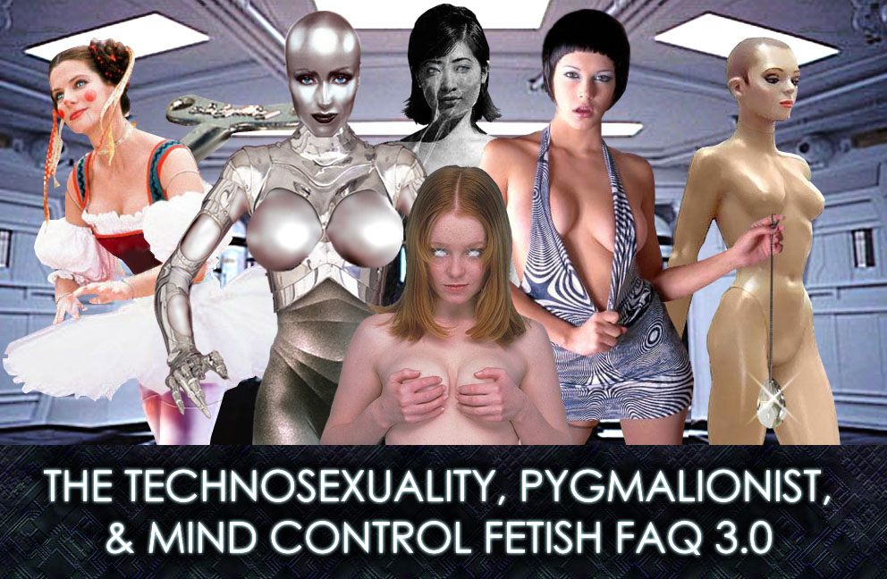

by Edward Gore, or WinterRose
as you prefer...

0.1 - FORWARD, COPYRIGHT & DISCLAIMER

Once upon a time, there was a page called www.asfr.com. And on this page, was a FAQ about the rather unique form of erotica there to do with sexy robots. (One I contributed to under the name Innocent@vnet.net) And the page unexpectedly flourished, and there was much happy mechanical hedonistic fantasy. Later, the author of asfr.com found that real life's demands prohibited him from updating his much-beloved page. New stories happened less and less. Related Pages like the Hall of Statuary, and The Mannequin Lover's Homepage disappeared. Finally, www.asfr.com went dark, and a great silent mechanical wailing was heard.

A wonderful thing happened then, as is usually the case in these stories when they look to be their blackest. The people who visited these once-pages came up with pages of their own. People that looked at those pages came up with pages of their own. The genre overlapped with other closely related ones and the limits were explored and pushed. And the community has grown. And though in this day, some of those newer pages have come and gone, the concept is still going strong. Even ASFR.com has come back online in a newer form…

But the venerable ASFR FAQ, as penned by Robotdoll and Leem, seemed to fall by the wayside. As of this writing, it was a difficult thing to find. It wasn't updated in what seemed like forever. And at this point, I re-enter the story. This FAQ is an attempt to provide a more current and inclusive coverage of all the things ASFR has grown into and crosses over with. It should be considered by no means complete. And submissions are certainly always welcome, and you'll be credited if you are okay with such. Comments and flames will be read and considered according to their merit.

Why am I combining concepts of Technosexuality, Pygmalionism, and Mind Control all in one FAQ? Cos I want to, shuddup already! Kidding. Actually, there is so much overlap between the three that I didn't want to write three seperate FAQ's. Because they can seem so interlaced and refer to each other so much in my own descriptions, I thought it better to have it all in one big file than three little files you might not be able to find all of at once later on.

This FAQ is Copyright © by Edward Gore, 2002, all rights reserved. This document is not to be sold or distributed for profit without permission. By continuing to read this document, you agree to absolve the author of all responsibility for personal or professional situations or mental states arising from your continued reading. You also undertake not to prosecute the author for any reason whatsoever. Excerpts from the previous ASFR FAQ are © by Robotdoll.

CONTENTS

1. TECHNOSEXUALITY

1.0 - What is Technosexuality?
1.1 - Okay then, what is A.S.F.R?
1.2 - So is this a new thing?
1.3 - Wait, wait, wait. You want to have sex with a Robot???
1.4 - So how does this relate to Pygmalionism or Mind Control?
1.5 - So what should I look for in a good Technosexual Fantasy?
a. START-UP/SHUT DOWN
b. VOICE
c. MENTAL STATE
d. MOTION & IMMOBILITY
e. MALFUNCTION
f. APPEARANCE
1.6 - So who's in charge here anyway?
1.7 - So, level with me. Are there women actually into this?
1.8 - So what media can I find some of this stuff in?
1.9 - Alright, sounds good! Where are these people anyway?
1.95 - The Future.

2. DOLLERS

2.0 - What's this about Toys, Dollies and Wind-Ups?
2.1 - I don't get it. Nice *SEXUAL* play with dolls?
2.2 - But what about this Dark Side you mentioned about the Doller fantasy?
2.3 - You mentioned student uniforms and some sort of Lolita fashion. Are
dollers a bunch of Pedophiles?
2.4 - So how does this relate to Technosexuality, Pygmalionism, or Mind
Control?
2.5 - So this isn't about real sex dolls you could go out and buy right now?
2.6 - Okay, I'm sold. Where would I look up Doller erotica?

3. PYGMALIONISM

3.0 - What is Pygmalionism
3.1 - Wait, wait, wait! You want to have sex with a statue???
3.2 - So what should I look for in a good Pygmalionist fantasy?
3.3 - So isn't this all a little one-sided?
3.4 - So this is a real thing? It's not just an internet fantasy?
3.5 - Super! So where can I find some Pygmalionist Erotica?

4. MIND CONTROL

4.0 Now, a warning???
4.1 Okay. Mind control is a fetish???
4.2 Okay, Smartguy. Tell me an ancient instance of Mind Control
4.3 So why would anyone be into this?
4.4 Consensual mind control? Isn’t the idea of Mind Control nonconsensual?
And if so, isn’t this a rape fantasy?
4.5 So, Smartguy, what kinds of Mind Control Erotica are out there?
a. PICTURES
b. FICTION
c. REALITY
4.6 Okay, but what elements should I look for that make a good mind control
fantasy or experience?
a. INDUCTION/ TAKEDOWN
b. APPEARANCE
c. BEHAVIOUR
d. HUMILIATION
e. CELEBRITY
4.7 Righty-o, Old Man. Where can I get some?

5. APPENDIXES
Appendix I - Other Related Fetishes.
Appendix II - People who were nice enough to contribute their opinions,
questions and answers.
Appendix III – Where the pictures came from and who made them.
Appendix IV - Who is this WinterRose person anyway?

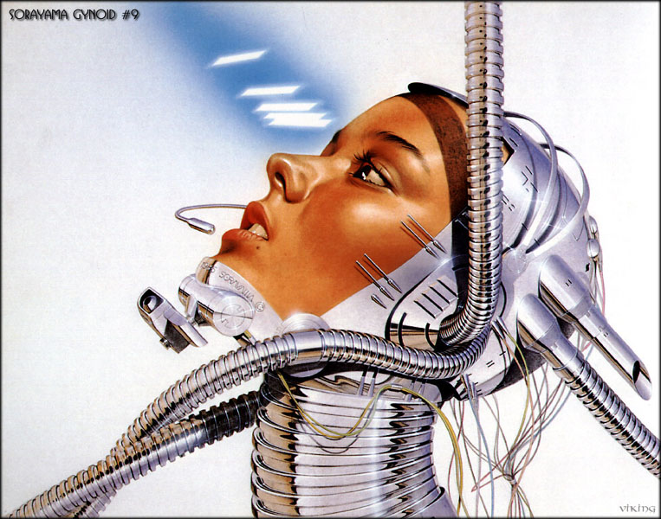

1. TECHNOSEXUALITY

1.0 WHAT IS TECHNOSEXUALITY?

"Tricky..."
-Deep Thought,
"The Hitchhiker's Guide to the Galaxy"

Strictly speaking, the term Technosexuality is a word used to get away from the oft-confusing acronym, A.S.F.R., which refers to the sexual interest in machines, robots, androids, gynoids and other sexual devices not really occurring in real life. And sometimes, ones that actually exist.

1.1. OKAY THEN, WHAT IS A.S.F.R.?

A.S.F.R. was the acronym for the original usenet newsgroup, Alt.Sex.Fetish.Robots. It was defined this way in the original FAQ by Robotdoll and Leem, and is still a fine beginning definition for those just getting started:

"The alt.sex.fetish.robots (ASFR) newsgroup is dedicated to the discussion of the concept of sex with or sexual attraction to robots and robot-like beings. This can range from metallic, non-humanoid machines to humanoid androids. Discussions can deal with specific fantasies, fiction relating to the topic and connected ideas like people behaving like/turned into human mannequins, dolls, toys, and other hypnosis and mesmerism fantasies that involve the mechanical/monotone response that appeals to the members." -Robotdoll, the ASFR FAQ, v 2.4

Sadly, the ASFR newsgroup fell prey to online advertisers that crossposted all manner of unrelated spam. The people who were actually there to see topic related material were driven out by the deluge to the degree that, as of this writing, the newsgroup is mostly dead. The group's acronym however lived on far past the group's demise as any useful place to meet and exchange information and ideas. Nowadays, it's been called Robofetish, Technofet, Technosexuality and among those that would rather things were kept simple, plain ol' A.S.F.R.

I refer to this as Technosexuality, or the people involved in it as Techno's. It goes far beyond a fetish for some, who may get offended if you trivialize the large and important part of their life that it plays by reducing it to the status of some fringe fetish. And besides, anyone who's ever tried to explain to an internet newbie or a mundane what a dead usenet group is and how it applies to your sexuality knows what an exercise in frustration that can be.

1.2. SO IS THIS A NEW THING?


Far from it. The human race's fascination with the concept of an artificial lover dates back into ancient mythology. How old is the myth of Pygmalion anyway? For those of you unfamiliar with the name, Pygmalion is the name of a sculptor from Greek Myth. He was aloof and cold to the women that wanted him, for none could match the beauty of the fantasy ideal he had in mind. He started eventually to sculpt from ivory the image of Aphrodite, Goddess of Love, but in the doing, fell in love with the statue and started to sculpt her into the image of his ideal. Letting that love guide his hands, he made her almost indistinguishable from life itself. Moved by his efforts, Aphrodite granted the statue, Galatea (Sleeping Love), life so it could return his love. Boiled down to it's very essence, the myth tells the story of a person that created the ideal lover.

The theme is seen in artwork through the ages. It crops up again in fiction and early automatons. It shows itself in our theater and opera. (Most notably a comedic opera by the name of 'Coppelia', by Jean Baptiste Lully in 1681) Though one might say the bomb that REALLY dropped and started it all in the 20th century was the early movie, Metropolis, by Fritz Lang.

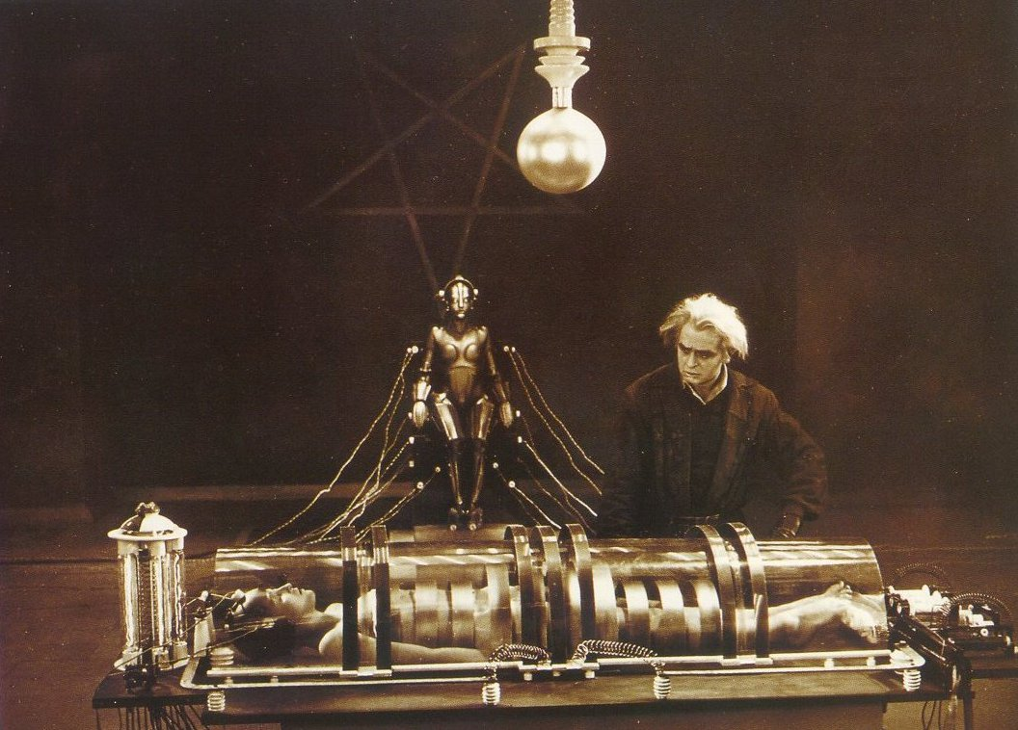
In this film, the mad inventor Rotwang kidnaps the heroine, Maria. You see he's created a robot to be a replacement for a woman he loved. But it needs a soul! So when the need to get Maria out of the way in the general run of the plot presents itself, he imprints the image of Maria onto his Robot. The scene itself is filled with the trappings of the mad scientist film before there ever was a visualized Dr. Frankenstein's lab. (Unless you count Thomas Edison's lost version.) The lady is in a confined little bed-thing with a big steel helmet on her head with wires coming out. Rotwang throws switches and levers. Chemicals boil, electricity flies, the robot on her throne is surrounded by energy and suddenly changes into the image of Maria. Though when she opens her emotionless eyes, they seem to glow with an inner light. IT'S ALIVE!

The mad scientist theme seems to perpetuate itself through all sorts of movies and shows later on. There's the Bride of Frankenstein. Any number of pulp serials full of hypnotized femmes. Early TV series (Star Trek, The Twilight Zone, My Living Doll, Etc...) Around the 60's however it seems that the people making the films and shows are starting to drop all the trappings of what Issac Asimov once called 'The Frankenstein Complex'. The robot men and women are no longer trapped by programming gone awry, sending them out of control to wreak havok on an arrogant humanity who shouldn't have tried to 'Play God.' We see now the advent of artificial beings that are just as 'alive' as their organic makers. And as we progress into the 70's and 80's, we see more and more instances of 'The Pinocchio Syndrome' That is to say, benevolent and sometimes not so benevolent artificials that want to be 'real live' people.


Of course we're still seeing the Frankenstein Complex. (Blade Runner, Westworld, The Stepford Wives, The Borg in Star Trek) but now there's the added tone of eroticism. We all know sex sells. But in the aforementioned movies, the robot is no longer just an artificial creation meant to carry out the labours of a man. The robot is now a receptacle for the affections of an increasingly alienated mankind. In Westworld and The Stepford Wives, we see mechanical targets for a misogynist backlash against women by an ever more emasculated male population in the wake of the sexual revolution. But in Blade Runner... Here we see more and more mature themes showing themselves. Here the machines aren't simply malfunctions. They've evolved thoughts and feelings of their own and want the respect due them as sentient beings. Priss (Darryl Hannah) is even cited as 'Your Basic Pleasure Model'.

Move forward Ten years and we begin to see explorations of interactions with more sentient artificial characters. Most notably Data (Brent Spiner) and Tasha Yar (Denise Crosby) in Star Trek: The Next Generation. They were notably 'Intimate' by Data's own description. More and more eroticized images of female machines are introduced by the Japanese airbrush artist, Hajime' Sorayama, who coins the term 'Gynoid'. Replacing the latin root Andros (male) in Android with Gyne (Female). And of course we get the resurgence of the Pygmalion Meme with movies like 'Mannequin' (Kim Cattrall).

And now we have the Internet. And then we start to see ASFR start to manifest itself as a cohesive whole. People who have been aroused by all these ASFR type concepts start putting together homepages that others stumble onto. They got themselves a FAQ together and eventually made themselves a chatroom and all sorts of message boards and galleries to share ideas and fantasies with one another. Erotic Fiction started showing up. And as image-altering software made it to the masses, altered photos of women (mostly) and men started to show up. This small and vocal group of fetishists, unsatisfied with the tidbits of erotica that suited them started to produce their own materials for sharing. Nowadays, we have people producing audioplays and videos SPECIFICALLY targeted at Technosexuals. Although rare, they are starting to get noticed more and more.

1.3. WAIT, WAIT, WAIT. YOU WANT
TO HAVE SEX WITH A ROBOT???

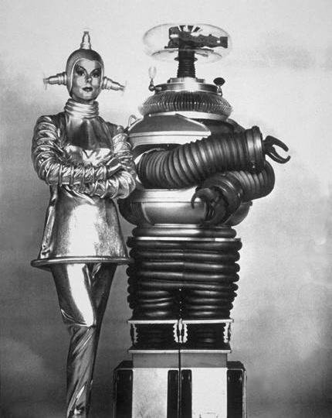
There's a question you may never get the same answer to twice. For my own part, yes and no. Do I look at that old robot on 'Lost In Space' waving its tentacular arms around and get all hot and bothered? No. Not hardly. Now when I look at the image of a polished chrome and flesh woman as painted by Hajime' Sorayama, or Jeri Ryan playing the infamous borg, Seven-of-Nine on Star Trek Voyager? You better believe it, gentle reader.

Am I indicative of the general mindset? Who knows? Different concepts float different people's boats. The idea of a person opening some access panel and showing circuitry and hydraulics underneath is enough to set some of us on fire. For some, it's seeing the supposed mechanical person damaged or malfunctioning in some robotic way. Some people only want the implication that the mechanical of their dreams is an artificial life-form, seeming completely human in every way, as in The Stepford Wives, Austin Powers, or The Terminator. The other extreme may be the streamlined jet-age art-deco look of Rotwang's 'Hel' robot in 'Metropolis', a completely inhuman, but stylized and sexually identified machine. And for still others, it's seeing said mechanical person being powered up, or running down. For some, the desired being may not have a physical form, existing as artificial sentient code in a computer mainframe.

And still the list goes on. Some are aroused by the artificial idea of a living toy or doll that can give or recieve affection. Others are aroused by transformations from or into robots. The transformation can be radically physical, from Borg-like implant installation, to a purely mental thing, as with intense brainwashing. It can be as subtle as nanotechnological conversion on the cellular level all the way to a brutal snuff-film-like chop-shop atmosphere.

The conversion, whether consensual or not in concept, into a machine is all some people need. Some need it to be very consensual or it crosses into rape fantasy. Others need it to be really non-consensual, or what's the point? For some consensuality never enters the picture, since robots don't think or feel, but simply perform their programmed tasks. For others, the idea of consensuality never enters the picture because hypnosis is a mental state that by it's very nature is consensual, otherwise it doesn't work.

For some, the fantasy is STRICTLY a fantasy only, the reality of which would never ever satisfy. For some it's the other extreme, being an ideal they would strive to achieve if given the chance, either in having the companionship of an artificial lover, or to actually become artificial themselves. And for still others, it's a chance to indulge in erotic roleplay and a rather specialized form of dominance and submission play. For some it's a chance to indulge in some arousing escapism by dressing the part in costume play or acting robotically. As many variances and combinations of those differences as you might ever expect to find in more mainstream erotic genres and communities, you'll find just as many in Technosexuality and its related cousins. The idea seems to be that on some level, mentally or physically, the person or object of desire is artificial and programmable. That's the only real constant. After that, all bets are off.

1.4. SO HOW DOES THIS RELATE TO
PYGMALIONISM OR MIND CONTROL?

The related cousins to Technosexuality I mentioned before are genres in their own right nowadays. Pygmalionism & Mind Control have their own followings in such a way that people into them might not ever look at a robot story or picture. But the concepts are quite similar in a lot of respects.

A fascination with control seems to be a constant between the three main areas. There's usually the constant of someone being in control; The User, Mad Scientist, Hypnotist, Sculptor, Master/Mistress, Programmer, Gorgon, Space-Alien, etc. And of course where we have the controller, we have the controlled; The Android or Gynoid, The Statue, The HypnoSlave, The Living Mannequin, etc, etc...

For the Pygmalionist, the control seems to involve quite a bit of the Startup/Shutdown sort of behaviours as well as the immobile and posable aspects of the Controlled. Whether the controlled person is a posable plastic or fiberglass mannequin, a tranced down living model serving as a mannequin or statue in a state of posable catalepsy (Hypnotically Frozen), or someone that's been petrified into a shiny gold or polished marble statue, toy or doll, the idea here is that someone has exerted a control over the controlled person's body or mind, rendering them into an artificial seeming being or object.

For the Mind-Controller, the idea of stripping a person of their will or personality, rendering the controlled into a mindlessly obedient and programmable 'Robot' person is a common theme in Mind Control fiction and pictures. Often in overtly robotic themed Mind Control media, there's the presence of all the trappings of transformation stories, turning the free-willed person into the object of desire mentally, and sometimes physically as well. Usually there's all sorts of technosexual-themed methodologies to bring this conversion about. The Mad Scientist's Lab, Slave-bot Nanites (Sub Cellular Sized Machines), An implanted, worn, or attached device. The methods by which technosexual themes can be applied to Mind Control erotica seem only limited by the imagination.

1.4. SO WHAT SHOULD I LOOK FOR IN A
GOOD TECHNOSEXUAL FANTASY?

If you ARE technosexually inclined, you already know what pushes your buttons. *AHEM!* This section I suppose is for those looking to understand some of the big turn-ons and turn-offs to do with technosexuality. And like I said before, the interests are as varied as the imagination can run sometimes. And no two people will say the same thing. But there are some very common themes.

START-UP & SHUT-DOWN: In this regard, the Technosexual will percieve the imagined person to be activated or deactivated in all sorts of ways. Some examples include:


In the classic movie Chitty Chitty Bang Bang, the character of Truly Scrumptious is dressed in an Austrian Dirndl, and made up to look like a wind-up doll. Benny Hill, the toymaker, winds her up and she proceeds to do a little song and dance number, after which she slows to a stop when her mainspring winds down.

In the late 1970's series, Buck Rogers in the 25th Century, the character of Buck Rogers is captured by the Draconian Princess Ardala, who copies his form and creates three android versions of him, subservient to her will. These android copies, she activates with a TV remote contol-like device, which causes the still and blank-looking Buck-bots to be illuminated around the eyes for a moment and come to life. And later when she decides that the artificial Bucks couldn't possibly satisfy her like the real one she can't have, she shuts them down again JUST as mercilessly, returning them to a still and inert state.

VOICE: The mannerisms of speech can create the impression that the person speaking is an artificial being. Sometimes the words spoken can be the source of arousal, speaking in long and drawn out over-technical descriptions of any given thing. Sometimes all that's required is a nonotone and clipped delivery, pausing for a brief beat between words or syllables. Or the person could just speak and refer to themselves AS a robot, every now and again making reference to their inherent robotic state of being, but in the dynamic tone of voice that someone as human as you or me might speak in. Some examples include:

In the early to mid 90's television series, Star Trek the Next Generation, Lt. Commander Data spoke in somewhat verbose and overly analytical terms, leaving emotional inflections for the most part recessed. However he spoke in normal fluctuating tones of voice and not in a monotone. The same delivery, in a colder and more emotionally delivered fashion at times, was given to us by Jeri Ryan as Seven of Nine in the later series, Star Trek Voyager. Seven of Nine spoke in more coldly technical terms as befitted a race of emotionless drones and machines. Where Data was attempting to find and experience human emotion, Seven of Nine seemed to resist the onset of her own recessed emotions until she hit a sort of critical threshhold, and then leapt in with both feet. The same delivery is given it's own spin by the actress Lexa Doig as Andromeda Ascendant in yet another Gene Roddenberry related series named for her character. In which she plays the artificial intelligence residing in the gigantic starship, and a humanform gynoid. As well, the actress Yancy Butler provided another take on the delivery as the gynoid, Eve Edison in the ill-fated series, Mann & Machine.

More monotone examples might be the way Majel Barrett performed as the ship's computer in the old Star Trek series with William Shatner. ( "WOR.KING." ) Any number of science fiction series wherein a person spoke in clipped monotones could be cited. Think of the old stereotypical hypnotic fantasy, where someone might have both arms out in front of them, staring blankly ahead at nothing in particular, saying, "I.HEAR.AND.I.O.BEY.MAS.TER." In some more well known Technosexual literary fiction, that brand of speech seems to be represented with the uses of periods breaking up the syllables as in the above example.


Still another form of how the mannerism and content in the speech can arouse is when speech is delivered in the opposite extreme. Like the classic stereotype of the 'airheaded bimbo', here the innocent, or vacuous mode of speech can denote an empty-headed toy or living sex-doll. As with the fembot at the beginning of the movie, Cherry 2000, or the Barbies in Toy Story 2. Or to drop into the example, "Dollies can't think silly! We just get to be pretty and be played with! Why would I need a head full of silly ol' thoughts to do that?"

And finally, the quality of voice can reflect the idea of being a robot. This idea is usually limited to audio or visual media where special effects can be added to the voice, like reverberation in the case of Andromeda Ascendant in Gene Roddenberry's Andromeda. The concept of Startup & Shutdown is also reflected here. How else can you create the low to normal, and normal to low sound effect in someone's voice? Like with a record player suddenly unplugged, and the singer's voice lowering and sssllooowwwing to a stop...

MENTAL STATE: There's an inherent submissive or dominant quality to the robotic. All too seldom are the instances in which the mental state is like that of your everyday Dick or Jane. The idea that the mindset of the controlled can be made to fit that of a fantasy lover is seductive and very close to that of the Mind Controller genre. Instances include:

In the second Robocop movie, the cyborg Alex Murphy is controlled by prime directives in his operating system that prevent him from acting out on his own in certain instances. There's even a scene where a lovely computer scientist has Murphy connected to her Computer Terminal, typing his thoughts in on the fly, programming him to believe he's very lucky to not have to think for himself, Murphy repeating the words as she types them.

In early and defining fiction pieces by the authors, Robotdoll and RC, there are instances of Robot Women assuming a dominant position, using implanted or installed technology to seduce, hypnotize and program people into robot-like positions of servitude. People who become the perfect servant for the one they wish to serve. In this instance, the controller becomes the ever-so deliciously controlled.

MOTION AND IMMOBILITY: In some fantasy, robots are not as mobile or as articulate as we human beings are. They move like... Well, like a bunch of clunky robots! Movements can seem stilted. Measured. They can happen with great precision and machine-like grace... or clumsiness. Immobility can denote a robot that's been shut down altogether. No power. Flat battery. Needs to be wound up or activated. An example?

The one example you may hear about before any other is the 'Doll On A Music Box' wind up dance from Chitty Chitty Bang Bang. This movie inadvertently influenced the young minds of thousands, friends and neighbors. And more recently, there’s been a stage production in England featuring this dance number as well. The clockwork way in which the actress moves, with foleyed wind-up ratcheting noises is enough to reduce your average techno to happy jiggly jell-o.

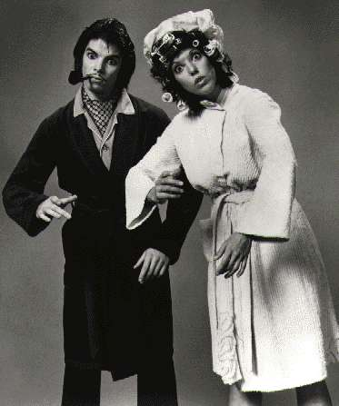
Consider the simple act of reaching for your coffee cup. Break that down into its individual parts: Turn head to orient vision on cup, Raise Arm, Extend Arm, Extend Fingers, Rotate hand to allow for grasping, Extand hand around cup, Close fingers around cup, Lift, and so on and so on. Breaking down movements into individual actions can seem mime-like. And some of the best examples in media could be found in the performances of more well-known mimes like Shields & Yarnell.

Shields & Yarnell were regulars on the now infamous Donny & Marie Osmond Variety Show in the 1970's. They were quite well known for their portrayal of 'The Klanks' a robotic husband and wife that moved robotically, with typically blank expressions on their faces. Later, Darlene Yarnell has been used in all sorts of robotic parts in which she moved in the same stilted mechanical fashion, most notably as the character 'Dot Matrix', voiced by Joan Rivers in the Mel Brooks movie, Spaceballs.

As of this writing, the best examples CURRENTLY viewable of this kind of robotic movement can be found at www.mannequeen.com, where you can download movies of women acting in a robotic or toy-like fashion.

Another example may be that of jerky, erratic, or nonsensical movement, as with a robotic malfunction. These can be as innocuous as adding salt instead of sugar to coffee, bumping into things as though your guidance mechanisms and spacial orientation circuitry or programming were malfunctioning, to grand-mal seizure looking jerks, twitches and spasms. All three examples of this kind of movement can be seen in the series of movies based on the Ira Levin novel, The Stepford Wives.

Someone with Tourette's Syndrome can exhibit a species of this behaviour, both verbally and physically. In this instance, this neurological disorder in normal human beings can seem JUST like a malfunctioning robot in some ways. Which brings us to...

MALFUNCTION: Let's face it folks. Robots can seem perfect. But when they go wrong, it becomes VERY obvious what they really are. A twitching, half melted, stuttering, limb-detached, smoking, or erratically behaving robot calls attention to the fact that they ARE a robot.




Some folks are very much into the idea of severe damage to a robot person. The exposed metallic skull peeking through Arnold Schwarzenegger's flesh leaves no doubt that underneath that cloned skin, there's a Cyberdyne Series 800 Combat Endoskeleton, Model 101. The same can be seen with some of the aforementioned examples of Commander Data, Seven of Nine, and Andromeda Ascendant. Battle Damage or catastrophic systems failure, as with the fembots in 'Austin Powers, International Man of Mystery' twitching, smoking and exploding in a pile of sparking sexy parts can be a big turn on for some.
Others see malfunction as a purely mental thing. A fault in one's program or operating system can cause a robot to stutter like Matt Frewer's digital character from the 1980's, Max Headroom. Indeed, Playboy Magazine took the idea a step further in the creation of their own playmate parody of the character, 'Maxine Legroom' as portrayed by the playmate Sandy Greenberg. Stuttering, random words or erratic speech patterns, speech slow-down or speed-up can all be indicative of malfunction and have been explored several times over to arousing effect in popular media for the Technosexual.

And of course malfunction invites the prospect of repairs, does it not? I perceive this to be another form of control and power exchange. The controller in this case decides how the controlled will function. Will think. Will act. And ultimately BE. The controlled is percieved to BE inorganic, heightening the fantasy, to be fixed or not fixed at the whim of the controller. And the prospect of open panels, exposed parts and wiring and inner workings brings us finally to...

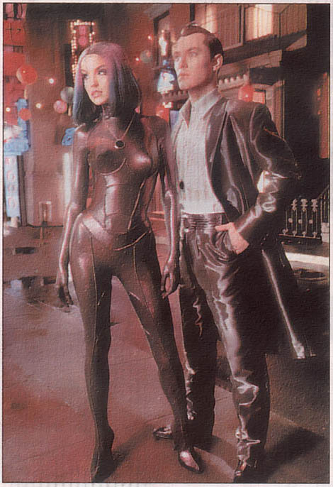
APPEARANCE: The old saying goes, if it walks like a duck, squawks like a duck, and looks like a duck, it's likely a duck. The same goes with robots for Technosexuals. The overt appearance of being robotic can take many forms, but will never fail to get some positive reaction out of your circuit-imprinted (As opposed to dyed-in-the-wool) Techno.

As was touched on before, sometimes the android or gynoid in question can look unquestionably human, as with The Terminator, The Stepford Wives, or Andromeda Ascendant. Someone who could walk past you on the street and you'd never look twice. Here the appearance factor seems to reside totally in behaviour or demeanor.

Then you start venturing into more obviously robotic people. The golden-skinned Commander Data for a start. The subtly implanted and corsetted Seven of Nine. Someone whose appearance is just too perfect. Too smooth, too flawless to be realistically human, as with the robotic prostitutes in Steven Spielberg's opus, A.I.: Artificial Intelligence. Indeed, there's a lot of crossover here with that of latex, spandex, rubber, and lycra fetishists, who also love that smooth, tight and sometimes robotic look.

And it just gets more robotic from there. After these more subtle examples, you get people painted overtly silver. People that wear full head or partial protheses or masks like with The Borg, or Kigurimi Masks from Japan, where people transform themselves into a living breathing doll-like version of their favorite fictional or animated character. Or further still, reflective metallic fetish clothing that obliterates individual feature, accentuating the fantasy that the controlled is nothing more than a sexy machine, as with the infamous Thierry Mugler Robot Suit, based on the gynoids of Hajime' Sorayama.

And finally, there's facial expression. The Blank Look. The 1000-Yard Stare. The Stoneface. They all describe the same thing. That emotionless mask that falls over the face of your classic robot, living statue, or mind-controlled slave. They don't feel. They don't think. And you can see that absence of autonomy or soul in their expression.

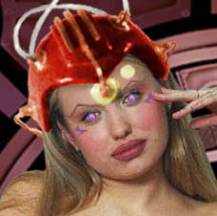
Sometimes that look will even be accentuated with the effect of glowing eyes, blank white or blank black sclera lenses that cover the entire eye. Sometimes it could be silver or circuit imprinted contact lenses. Sometimes eyes that look like featureless pinballs in the head as with cyberpunk-ish fiction. In the aforementioned movie Blade Runner, the replicant characters were shot in such a way as you caught the reflection of the actors’ retinas on film, like when you shine a flashlight at a cat and their eyes seem to glow. Sometimes the eyes will be left un-augmented, but made to look as if the irises were really constricted or dilated. Or just rolled up as if looking into the back of their forehead inside their skull. If eyes are the windows to the soul, they're windows to the absence of one as well.

…or are they?

1.6. WHO'S IN CHARGE HERE ANYWAY?

There is the question of who's usually the controller or controlled in these types of fantasies. Isn't it very like the misogynist male supremacist stereotype put forward in The Stepford Wives? Indeed, the term Stepford Wife has been likened to a meek, obedient hyper-effeminate woman who has no sense of pride or self-esteem in modern society, as with the old stereotypical Donna Reed. (Nevermind that she was the one of the first woman TV executives of her day.) Is it all about men objectifying women?

Gracious, I hope not! The women in my life have all been powerful and capable people, worthy of nothing less than total respect as individuals. I'd certainly hate to imagine their thinking I wanted to reduce them to a set of remote controlled tits and boobs, with three orifices, preferably tight and moist.

There does seem to be a cathartic release for some men as a backlash against more abusive forms of man-bashing liberated women in Technosexuality. I couldn't respect that myself, but I'm not about to pretend there's not men in the world that would be just fine with a remote control he can point at the bitch to shut her the hell up so she can get on with the business of being a perfect little fellatio device. On the other side of the coin, there's likely women out there that may feel the same way about men. Basically wishing they had a remote that they could turn this dildo with legs on and off with at her command, while not having to listen to his self-important yap.

There are people like that out there. The Technos you'll find in the online community, however are probably not going to be those people. Technosexuality has been described not so much as the objectification of people, but the humanization of objects. Creating the ideal lover in the Technosexuality sense implies that the artificial partner you create or role play with is doing this willingly because it's what they were programmed to do. (Or agreed to ACT like they were programmed to do.) It's why they were created. There's no guilt or repercussions. You remove the possibility for rejection or mutual abuse or hurt or misunderstanding. Remove the human equation and all of that possibility for hurting another human being or being hurt goes away. Talk about your 'safe sex'! Your robot lover will never get sick. Make you ill. They'll never age...

Umm, anyway. The Technosexuals you’ll probably find online are going to be very intelligent, sensitive and respectful people on the whole. They don't follow Isaac Asimov's 3 Laws of Robotics or anything. But if you are a Techno, these are people you probably share a lot in common with. The common joke among Technos is that each and every last one of them at one point thought they were the only one. They're not. If you are one, YOU'RE not. If it happens to be someone you know instead, THEY'RE not. And they're likely far from being some sort of degenerate pervert. It just seems in my own experience that nice and respectful people are the rule instead of the exception. As with dealing with any real person, exercise common sense. There are creeps out there. But it seems the Cool Person to Creep ratio among Technos is weighted very heavily AGAINST the creeps.

This is all very nice, I hear you saying, but that doesn't answer the question who's in charge here. The idea, if you wanted to put it into simple terms, is a very specialized version of Dominance and Submission. And it seems to blanket and overlap several different aspects of itself in as many diverse ways as BDSM does. And even though there's a prevalence of women as the sub imagery out there, there's just as many stories out there where the woman or fembot is in charge. So while it may seem that men are on top in this community, I don't believe that it was by choice. If anything, it was by default. And I think we'd certainly welcome more women taking charge and meeting men as equals on the playing field, the internet, or in the bedroom.

The 'Sub' that wants to be a dolly for you to be played with and squeezed and cuddled could be said to be indulging in a very specialized form of Age Play. (Role-Playing where one plays a different age from one's reality. Also Infantilism.) The terminator/terminatrix type robot dominant may be indulging in a sort of topping that removes all uncertainties and guilts from being dominant. A robot dom, after all, doesn't have to worry about going too far with their sub if they're only following the programming their sub put into them. (It doesn't feel pity or remorse! And it absolutely will not stop!" -Kyle Reese, 'The Terminator') Indeed, such a safe way of domming might even be considered by some to be an ideal way for a Sub to Dom. They're in command, but they're also completely subservient to the needs of their bottom.

The person that wants to immobilize or be immobilized in a roleplaying sense or hypnotically may be looking for that same thrill and sense of being catered to or helplessness that bondage enthusiasts crave when being mummified or elaborately tied or chained. What kind of ultimate control might your Master or Mistress have over you if they can freeze you without a link of chain or fiber of rope? In this case, they own you in your skull as much as they do outside.

And of course there's the more generalized ideas to do with dominance and submission. The ideas from the media are really well used here. Who will be a more heartless and unrelenting master or mistress than the machine, the mad scientist, super-villain, artist that sculpted you, 'evil'-hypnotist? Who is more helpless and subservient than the pulp-science-fiction damsel in distress, fembot, living doll, hypnotized sub? Are there more archetypes than these? You betcha! There's likely a dominant or submissive fantasy figure for every person out there that ever saw a Techno concept in a movie and had to shift in their seat.

1.7 - SO, LEVEL WITH ME.
ARE THERE WOMEN ACTUALLY INTO THIS?

Believe it or not, yes there are. Friends and neighbours, I kid you not. We men folk probably outnumber them 10 to 1 in the online world. Half the women you meet in chat are likely men. Some women that post are even assumed to be men out of hand, as is the case with a favorite Technosexual/Mind Control author and artist I'm quite a fan of. And women that lurk without posting sometimes NEVER reveal their actual gender. And it gives some of us fits!

It's an understandable situation however. Women online today tend to get pounced on immediately by any man that may perceive them to have even a vaguely female sounding online name. Sometimes to the degree that some women will post under a male-identity out of sheer self-defense! It happens to me all the time. More than likely before someone has the common decency to try and chat you up, they're asking you in abbreviated terms, "A/S/L????????" (Age, Sex, Location.) Geez, I don't even rate a 'Hello'? Sound familiar ladies? Every time you've ever been propositioned 8 times in a night and wished these guys knew what it was like, it's very likely your average Technosexual, Pygmalionist, or Mind Controller will know your pain and understand what you're talking about. At least half of them have been there and have the lousy T-Shirt to prove it.

This is not to say that Technosexuality or its related forms of play are strictly online phenomenon. There are very happily married couples out there that indulge themselves in this kind of roleplaying without ever seeing the inside of a chat-room or bulletin board. Or at least, so it has been suggested to me. And by some reports from people online that seem to love each other very much in the old real world, there's good reason to believe it.

Women are often also under a form of societal pressure to feel shame about acting submissively in relationships and sexual roles. And there's the stigma of the Stepford Wife. Often, I would imagine, there's guilt. You know. Something along the line of, 'What kind of woman am I to even consider being turned on by being a submissive or dominant sex object???'

I'm here to tell you, ladies, at least from my own point of view, that it needn't be that way. The choice to give your obedience to a controller or will up for programming is a choice YOU make. In my own eyes, the willing choice to take or give control, and thus render one's-self emotionally vulnerable in this kind of sense takes the kind of iron will any warm-blooded Techno would only be too happy to polish up for you. As much as it can be seen as a negative thing, it can be a HUGELY empowering thing. By indulging in this fantasy, you hold the desire of your partner in your every movement and word. The totality of your existence is what we'd be aroused by. Talk about topping from the bottom. Your partner may be your controller, but you have every bit as much control as your partner does... if not more. You as the controlled or controlling 'sex-object' maintain the fantasy and make it real. It doesn't happen without you. You are essential and integral. What could be more empowering than that?

1.8. SO WHAT MEDIA CAN I FIND SOME OF THIS STUFF IN?

This is a hot and cold subject. Where can you find Technosexuality in the media? Everywhere. Just be prepared to dig a little. There is a thing I've heard termed as the 'Woulda/Coulda/Shoulda' factor in a lot of mainstream television or movies. It WOULD have been better if said Robot Guy did this. Robot chick COULD have done this and it would have really rocked. They SHOULD have had the mechanical person totally act this way.

The moments in a lot of mainstream movies are usually all too brief and fleeting to justify going through an entire movie or show to see. An episode of Andromeda for example may feature a total of 15 minutes of Lexa Doig on Camera. And maybe she'll act robotically once. Or twice. For maybe 5 seconds. Or the larger and more well known example might be the aforementioned movie, Chitty Chitty Bang Bang. The movie is huge folks. And the wind-up dance sequence that Truly Scrumptious performs for the King of Vulgaria is maybe 3 minutes, if you take Dick Van Dyke's part into it.

Now, would anyone sit through this longer than two hour children’s movie just to see three minutes of it? You're darn tootin' we would! As a matter of fact, there are folks who've gone as far as sampling out digital clips of the films so you don't have to watch the WHOLE movie. There are people that have made quicktime movies of commercials just because of a timestopped moment. People that have dug through their old videotapes and made movies of those crucial but brief moments in things like Wonder Woman, Charlie's Angels, or obscure movies of the week from older network TV.

There are made for TV movies from cable channels. Network Series that lasted only one season and were never picked up like Mann & Machine, My Living Doll, Automan. There's any number of sight gags and themed sketches from variety shows like Mad TV or Saturday Night Live, one of which features the infamous Britney Spears as a living Barbie Doll. (Self-parody perhaps? She was also a fembot at the beginning of Austin Powers: Goldmember) And that doesn't even get into all the commercials or songs, or music videos, novels or comic books. There are in fact so many, I am not going to list them all here. People more dedicated to that purpose than I have made entire pages devoted to chronicling every last instance of Techno, Statue, or Mind Control instances in Television, Radio, Fiction, Comics, and the Movies. I shall include links to those pages at the end of this FAQ so you can go do your own researching.

And when you do go looking? You'll find that these people are very much aware of the niche they occupy. And they're no longer satisfied with just sifting the deluge of product from the entertainment mills of Hollywood for the occasional nugget that gets them into that aroused place. You'll find that any number of authors have sprung up to produce erotic fiction that caters to what excites them. Digital artists have taken to photo-manipulating stills of popular celebrities or internet porn into what satisfies their Techno, Statue, or Mind Controlling urges. And some rare few have gone beyond that, producing original videos or audioplays of the aforementioned fiction. I should know. Trust the Rose on this. I have CD-Rom's FULL of this stuff. And no, don't mail me asking for copies. I have a 56k connection and no money for such things. You'll have to find them yourself. Hey, at least I'm pointing you in the right direction, yes? Which leads me to...

1.9. ALRIGHT, SOUNDS GOOD!

WHERE ARE THESE PEOPLE ANYWAY??

Now that you're ready to look for some of the things that turn Techno's on, where do you go to find these people? How do you get in touch with these people that share your interest? Where are some people you can talk to to get advice on living with and exciting the Techno in your life? What? I haven't answered enough of your questions already??? DAMN PEOPLE!! *smile*

Well, I'm glad you asked. There's LOTS of nice friendly places, clubs and bulletin boards where Techno's go to congregate, exchange information about the latest movie or show tidbit. Work out new plots and stories. Role-play online. Internet Relay Chat rooms where people talk in real time and cyber-sex with one another and generally be terribly supportive. One is 'Fembot Central', a PHP style BBS that's WAY user friendly and segmented into nice little sections where you can quickly find what you're looking for. From there, you could find the addresses into IRC rooms and Yahoo Groups and Lycos Clubs and fiction archives and personal pages with links to all the other places that the people on Fembot Central may have missed.

Here's some URL's to all the majors to get you started out of my own bookmarks:

Fembot Central
http://www.fembotcentral.com/bbs/index.php

The Female Android Cornucopia
http://monza.yi.org/Preview/

The Many Realms of Fantasy
http://www.many-realms.net/

The Legacy of Timeless Beauty Story Arhive
http://www.many-realms.net/LTBSA/index.html

Robo-Lover's ASFR Fiction Archive
http://members.aol.com/robolvr/fiction.htm

The Master List of ASFR-Related Material
http://www.many-realms.net/master-list/list.html

And my own sites...

The Psycho Technoid Theater of the Wired
http://psycho.technoid.theater.web1000.com

The Bestiary - The WinterRose ASFR Homepage
http://winterrose.web1000.com

The Technosexual, Statuephile, Dolly, & Mind Control Haven
http://clubs.lycos.com/auth/live/Directory/CommunityHome.asp?CG=affcmm8fdfah386m0188nohtss

The Mind Control & ASFR Artists' Prop House
http://clubs.lycos.com/live/AUTH/Directory/CommunityHome.asp?CG=5utd48a67nskh9d12ceqdm1n3s

Privatepages.com - The Realm of Enchantment - The WinterRose Galleries
http://www.privatepages.com

1.95 - THE FUTURE.

"We are all interested in the future, for that is where you and I are going to spend the rest of our lives. And remember my friends, future events such as these will affect you in the future."

-Criswell, 'Plan 9 From Outer Space'.

So is this all just science fiction and unrealistic longing? Today it is. We may or may not see the advent of robotics in our lifetime. There are so many factors involved that it isn't even funny. But the idea is inevitable, in my own view. The idea of robots seems indelibly branded on the consciousness of the world. Entire branches of science are devoted to its research to bring it about.

There are innumerable papers written out there for your perusal about the coming convergence of evolution into hybrid mechanical/biological creatures as a species. There are people out there researching mechanical limbs. Mechanical organs already exist in some primitive, and sometimes NOT so primitive fashions. In the last two years, it's been loudly decried that the first cyborgs exist, through microchip implants. Considering the need for mechanization of body parts that have been damaged or worn out, there's really no reason to believe it will stop there.

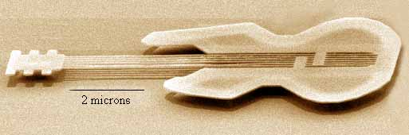
Then there's nanotechnology. Like it or not folks, it's coming. Nanotechnology has already advanced to the point where a guitar has been sculpted no bigger than the size of a human blood cell. (www.lutherie.net/ nano_gtr.html) World leaders have already anticipated the advent and are preparing for it, as noted in plain old scientific journal articles you could look up yourself.

It's been theorized that colonies of nanomachines could manufacture and replace protein stem-cell caps, halting the biological clock and the effects of age. Lace our bones with diamond or titanium. Increase the tensile strength of the softer parts of the body, in effect, making us capable of surviving things like a 3 story drop so well, we could just get up and walk away. Colonies that protect us from ultraviolet sunlight. Colonies that seek out and destroy cancerous cells with mutated genetic structures. Colonies that produce oxygen within us, or enable us to metabolize the oxygen from seawater, conceivably opening up the frontiers of the rest of our planet to us beneath its oceans. And of course that doesn't even get into the possibilities for finally opening up the ol' FINAL FRONTIER. Post humans or Robotic humans would be the ideal beings for the vanguard into space. To the moon. Or Mars. Or maybe even beyond.

This doesn't even get into the possible uses for brain augmentation. Nano-colonies that seek out and replace or rebuild failing neurons. Or the enhancements for memory and recall or expansion of intelligence. And once that's advanced far enough, it isn't that hard to imagine that once a person is more nano than neuron inside their skulls, that the consciousness of that person is more program than bio-supported animus. Could the human consciousness be downloaded from a failing body into a computer network or robot?

Consider the effect on lifekind. How resource friendly would post-humans be in a world capable of safe energy resources and recycled materials? "Boy am I hungry. I need to go soak up some rays. My batteries feel a little drained. I'll set my emulator to perceive the sunlight through my solar panels as tasting like chocolate."

And these post humans, still being living, thinking, feeling beings will likely still want to be able to show their affection for one another. By necessity, there'd have to be a post-human or robotic-human equivalent of sex. Or would it be that necessary without the biological drives that we're in thrall to as humans? As beings that could potentially live for millennia, how would that bear on one's drives socially or romantically?

If we still wanted to produce offspring, how would it be done between human and machine consciousnesses? Perhaps a batch of donated nano-programmed sex cells could be produced with the preserved genetic code of the post human for combination with the sex cells of the biological significant other's. How would two purely code-based post human intelligences work it out? Might they copy and combine their programs into an new combination of themselves? Might they merge completely into a new consciousness?

Is it all really that farfetched?

Maybe.

Men and women are already having sex with robots to some degree. CRUDE robots. But by the strictest definitions, robots all the same. The vibrator. The mechanical penis pump. They're both mechanical devices meant to do the work of a man... or woman. But it doesn't stop there.

With the advent of things like Silicone-Based sex dolls like RealDolls and SuperDolls and any number of japanese equivalents, the idea of sex with robots becomes more and more realized. These dolls are said to be solid and realistic feeling. And in some people's opinions, SUPERIOR to flesh and blood human beings. They're being sold as we speak to people for between 3000 and 6000 dollars US. Completely customizable in appearance; people are already deviating from the constraints of the traditional human design, having dolls made for themselves in colours straight out of science fiction. Female designs with penises AND vaginal openings. MALE designs with penises and vaginal openings. It would seem that the only constraint on design is whether or not it can be built. And the technology is improving all the time.

Does that make these dolls robots? Not if they were just dolls. But they're even more sophisticated than that already. Some of them have sensors implanted in them at strategic spots. Plug your doll into your PC and use the appropriate program to define responses? It's not inconceivable that when you touch it on a certain part of its body, it replies to you with the programmed response right out of your PC's speakers. The voice of anyone you can sample speaking being available to you. And that doesn't get into the mechanically assisted vibration possible in a mouth, anus, penis or vaginal opening. And that REALLY doesn't get into the fact that you can buy these things built to actually MOVE under the power of motors meant to make the hips rotate or thrust back and forth. Or get them with steel skeletons within, making them quite sturdy or posable.

Sound like programmable sex machines yet? In their basic and not so basic form, yes indeed. Is there any reason to believe that the technology will stop there? I very much doubt it. Based on the success of existing technological alternatives to sex, research into nanotechnology, the scientific research being poured into robotics and computers, and the research into biological and technological convergence? This isn't just weird science fiction conspiracy X-files theory. The research is taking place while you're reading this FAQ. The documentation is something you can search out yourself. This is happening. Robot sex isn't a matter of if, ladies and gentlemen.

It's when.


2. DOLLERS

2.0 - WHAT'S THIS ABOUT TOYS, DOLLIES AND WIND-UPS?

Okay, okay, I hear you saying, I can sort of understand about the robots thing. But there are people out there that are sexually excited by toy dolls?? Well, I'm glad you asked me that too. There is a section of the community completely and actively devoted to this idea. It sort of falls between the gray area of Technosexuals and Pygmalionists. So it gets its own section between the two.

There's a way gentle side to the whole robot and statue thing that manifests itself in the Doller community. People here tend to be more sexually aroused by the idea of a living doll, toy, stuffie, or wind-up automaton. Or actually BEING one, or being transformed into one. Among dollers, some of the big attractions seem to be imagery, assuming the role, dressing the part and some VERY nice play. It can have it's dark side, like anything can. But for the most part, this one's a very bright and happy part of the whole.

Here's where you can also find a lot of the more cartoon and Japanese animation-based ideas, as well as some overlap with all the other areas to do with this FAQ. As well, it ventures into the territory of Costume Play, Age Play, alternative fashion styles, student uniforms both Western and Japanese, some fashions are even geared toward a sort of doll-like look referred to as 'Gothic Lolita'.

2.1. I DON'T GET IT. NICE *SEXUAL* PLAY WITH DOLLS?

Well, yes.

I believe that there's an operative mentality here that looks for a gentle more playful side of the kind of sexuality this FAQ deals with. There might be an emphasis on innocent play, nurturing or cuddling without any need for actual intercourse whatsoever. One person may enjoy just snuggling up with a lovely dolly and spooning all night in a cuddle. Another person may really enjoy the dressing up and cosplay oriented aspects of it. Another person still may really enjoy getting into that whole innocent, (And sometimes completely vacuous) mindset, where the one that plays with you makes you feel loved and treasured.

2.2. BUT WHAT ABOUT THIS DARK SIDE
YOU MENTIONED ABOUT THE DOLLER FANTASY?


The Dark Side you say? Well of course there is one. Being nonconsensually turned into a doll? Reduced to an empty-headed plaything and having your mind taken away, or worse, being made entirely un-intelligent and dependant on another? As many mad scientist and evil sorcerer stories as you can think up for mind control, transformation or robot stories, the archetype of the living toy can be applied to that. As a matter of fact, some of the darker transformation stories are all about real people being turned gradually into machine augmented or magickal fuckdolls. There's certainly the idea of an EVIL toymaker as well to go along with the archetype of the Mad Scientist.

2.3. YOU MENTIONED STUDENT UNIFORMS AND SOME SORT OF LOLITA FASHION. ARE DOLLERS A BUNCH OF PEDOPHILES?

Hell no.

That bears repeating, in boldface, expanded type, Capital Letters, Quotated and Underlined with many exclamation points. So let me repeat...

**"HELL NO!!!!"**

There are childlike aspects to doller play, especially since the main aspect is to be the adult sexual image of a child's plaything. There is a lot of costume play where one may seem physically or mentally regressed, and indeed there is some Age-Role-Play happening there in some instances. But the sexual aspects of Doller play, as with any play where there is a transfer of power, mentally or physically is about the mutual trust and consent between adults only.

Do not kid yourself. Pedophilia is about the abuse of power and taking it away from another by abusing the trust of a child. It isn't beautiful. It's not pure. It isn't even remotely good. It's rape, pure and simple. One of the worst kinds of rape there is. This is the rape of innocence and trust. If you are thinking about raping a child, do not pass go, do not even keep reading into the next paragraph. Close this document immediately and get out the phone book. You need to contact professional help immediately and get this sorted out before you hurt someone. Before you possibly destroy their life.

2.4. SO HOW DOES THIS RELATE TO TECHNOSEXUALITY
PYGMALIONISM OR MIND CONTROL?

There's overlap in all three actually. There are mechanical aspects to being a wind up doll, or proscribed movements. Lay her down and her eyes close. Pull her string to hear her say 'Mas.ter.' Squeeze his tummy and hear him say "Ma-ma!" Mainly the aspect of transferring affection to a person in the role of an object. And let's face it folks. A person becoming a 'Barbie' like doll is literally being transformed into one of the first images we associate with beauty as children. As a doll, we become cute, adorable, or beautiful.


As regarding Pygmalionism, well, Dolls don't move silly! They can be sat down, stood up. Dressed. Undressed. Displayed. Put on a display post. (Orrrr a display saddle with a special post for a dolly mounting hole. Or holes, as the case may be.) As with Techno's, a doll is also sometimes shiny or has an artificial rubber or cloth texture. That shiny yet immobile innocent beauty can be compelling. Especially when said doll trusts you and feels safe enough with you to BE that docile or still, or let you put him or her in that mental fun zone.

Which brings us neatly to the Mind Controller's stake in this one. I've read and enjoyed more than just one hypnotic induction geared to put the reader in a happy sexy simple dolly frame of mind. The experience can be VERY relaxing and liberating. As much as obedient hypno-slaves, robots and statues don't have to worry about anything, it's almost twice that again for a doller in the role of the toy. Not only do they not have to worry, they more often than not go into a lovely place where they're very loved, cared for, and desired by the people that play with them. It's not unusual for some of that to carry over into waking life. I've even read first-had reports of people who found themselves smiling and becoming a little more giggly than usual in every day life. Like I said. This can be a very powerful place.

2.5. SO THIS ISN'T ABOUT REAL SEX DOLLS YOU
COULD GO OUT AND BUY RIGHT NOW?


Well, I mentioned them before to an extensive degree in section 1.95. Sex dolls are FAR from just the somewhat woman shaped poly-ethylene balloons you remember from so many clichés. You know. The ones that look nothing like the picture of the porn-starlet on the box? They've evolved about as far from that as humans have from rhesus monkeys. Similar animals. ENTIRELY different species.

Back in 1995 or 1996, a company called Abyss Productions, who specialized in creating prosthetics and movie special effect people had the idea that they could make an entirely realistic sex-doll using a solid construction with an articulate skeleton and silicone rubber based on molds from real women and sculpted parts. The results are enough to make any person into dolls, or realistic, yet artificial looking women that you could actually have *AHEM* relations with fall off their computer chair. They're called Realdolls. And Abyss seems to have really taken off since then, with customizable face body-type combinations. And they even make males, or any combination of the two sexes they can realistically combine.

Since then, there are other companies out there that make products along the same line. Some have vibrating implants. Some are based on life-casts from famous porn-stars. Some actually have rudimentary sensor networks in them that can be connected to your PC. Touch her here and listen to your PC speak in her voice how much she likes it when you do. Indeed, we're not talking toys for tots. These dolls are adults only. Especially when you look at the price, which usually starts in excess of $4000 or $5000 dollars U.S.!!

2.6: OKAY I'M SOLD. WHERE WOULD
I LOOK UP DOLLER EROTICA?

This may or may not be the smallest individual facet of the surrounding fetishes. It depends on how broadly you want to define your search. If you're just looking for someone dressed as a Barbie or Raggedy Andy, you might find yourself limited to a very few costume shop pages. If you want to include cosplay and Kigurimi pages, it gets a little more diverse. If you include people that are into masking, it gets even more inclusive. If you want to include silicone dolls, expand it even further still. Here's some links to get you started:

Yahoo Groups: The House of Living Dolls
http://groups.yahoo.com/group/houseoflivingdolls/?yguid=77475150

Abyss Productions: Realdoll.com
http://www.realdoll.com/intro.html

Coverdoll Magazine
http://www.coverdoll.com/home.html

The Living Doll House
http://www.socket.ru/%7Eldh/

Mannequeen
www.mannequeen.com

Superbabe: The Ultimate Lovedoll
http://www.superbabe2000.com./frame1.html

There. That ought to be enough to get you started. The links you'll find from these pages will certainly lead you to more and more Doller resources. Have lots of fun!



3. PYGMALIONISTS

3.0: WHAT IS PYGMALIONISM

In the past, this has been called statue fetishism, or if you want to get into a REAL 20 dollar latin word, Agalmatophilia. I like to call it Pygmalionism, as it's called by BDSM people that really don't know that much about it, after the greek myth of the sculptor that started to create a statue of Aphrodite, and in the end, sculpted her into his ideal woman and named her Galatea. And fell deeply in love with her.

In any case, to say that people into this sort of thing are aroused and excited by the immobile human form. The object of affection can be living or any material one might imagine. The object may be rigidly solid, or fluidly posable. So long as there is some statue-like immobility involved.

3.1 WAIT, WAIT, WAIT. YOU WANT
TO HAVE SEX WITH A STATUE???

As before, the answer is no and yes. For my own part, the thrill here isn't a solid stone statue. It's an immobile posable living breathing human being. One that can be interacted with on more than just the level of visual appreciation. Like before, I'm no-where close to being indicative of the general mindset. It's different things for different people, just like with any area of adult interest. My assumption is again that the underlying thing is a sort of bondage-related exchange of power.

3.2 SO WHAT SHOULD I LOOK FOR IN A
GOOD PYGMALIONIST FANTASY?

As mentioned before, there's all sorts of operative roles and roleplaying involved here. With that of the controlled, or in this case, the transformed, there's the victim of an evil spell, curse, or Gorgon's stare. There's the Living Mannequin. The person immobilized, polymerized, or plasticized by some potion or mad-science doodad. The hypnotically frozen living statue. The person turned to wax, gold, marble, plaster, alabaster, plastic, ice, crystal, fiberglass, etc... etc... Anything you can think up that might involve being a statue or immobile person is fair game.

In some cases it's not even the state of immobility as the actual petrifaction, gilding, dipping, waxing, freezing, etc. For some it’s the ACT of transformation from a mobile and seemingly living being to an immobile seeming object. Some seem to relish and collect pictures in which the subject of transformation seems confused looking or perhaps caught off guard or abruptly terrified or in the middle of some mundane task. All the better to overlay with the texture of the substance they find most arousing.

And yes, some people out there have specific substances that they go for above all else. For some it's not the substance, but the lustre or texture of the 'skin'. That too perfect mannequin plastic shine or matte finish that a person may have. Several digital artists have become adept at isolating exposed skin in a picture and playing with the contrast and brightness until they achieve a uniform artificial look, like unto a mannequin. To leave as dull or make as shiny as they like.

Some are really into metals, the hard perfection of steel, bronze, copper, lead, chrome, silver or gold. Others are into the classic plaster, marble or alabaster look, denoting the look of a statue from myth, sculpted by some artist extraordinary, or petrified by a Gorgon.

Still others are quite into seeing the ASFR-like start up and stopping part of the transformation itself, to see the features slowly or quickly change from the normal hues of life to that of their favourite substance. Hearing the voice slow and quiet away to nothing, or cut off abruptly in the dry crackling of quick petrifaction.

Still others have their world rocked by the doll-like pose-ability of the living mannequin or hypnotically frozen statue-person. Free to dress, undress, insert things into or impale one’s-self upon, all the while leaving the immobilized person completely aware of their situation and the helplessness in the face of an arousal they have no choice but to experience until their minds go quite away, leaving a frozen living breathing orgasmic monument to lust.

And yes there are several types of roles for that of the immobiliser. There’s that of the Gorgon, the Visual Merchandiser, the Scientist/Inventor, the good or evil witch or wizard, Super-Villain. And that's just off the top of my head.

And as with ASFR, any combination of the above can suit anyone at any given time. I myself would completely dig a completely reflective gold Milla Jovovich from the neck down, only as warm and yielding as flesh. Completely mobile, freezable or posable to any degree I happened to want at the moment. Others may be just fine watching a woman or man climb into some science fiction hypersleep tube and see them frost up as they drop into suspended animation. Still others wouldn't need a tube for that at all and are just fine with the idea of someone encased in ice, like icicles that cover pine needles in the snow.

Some don't need the ice at all. There is a series of telephone wireless commercials that star Catherine Zeta Jones, in which she'll walk into a scene and say 'Freeze'. And EVERYONE stops around her, time-frozen in their tracks. Which is another LARGE part of this side of the fetish. Timestop. As with the old movie, 'The Girl, The Gold Watch & Everything', where Robert Hays clicked the magical pocketwatch his relative created, and he remained mobile in a frozen world, free to manipulate things and people (and the yummy Pam Dawber) around him until he started time back up again.

And for some folks, the immobility doesn't even need to be total. There is the idea in some bondage erotica that the person all tied up struggling against their bonds is quite exciting. If the immobilized person could say look around using only their eyes, or move only their lips, they might be able to denote a full awareness of their situation all that much more, speaking through a clenched jaw, or following the immobilizer with their eyes.

In some instances, this carries over to the immobilized person being able to move for the most part, but they've been frozen to one spot! Like they've trodden in a puddle of super glue and have suddenly become rooted to the floor. Or had their hand glued to their hip. Or breast. Or sex. Or whatever. This falls in line with bondage themes to do with proscribed or limited movements. Only this isn't cuffs, rope and chains. This is just good ol ACME glue like you remember from the cartoons. Or perhaps it could just be a posthypnotic suggestion.

Going back to the other extreme again, there's the fantasy of making someone a statue for an indefinite period. When the immobilized person is sealed inside their mannequin shell, vibrating whatsits against their hottest parts, driving them to distraction? Or when the bliss-like calm and arousal starts to build and build inside the petrified or gilded statue-person, one part of the tension for the immobilized might be, 'Oh god, how long am I going to be left like this??' An hour? Days? Weeks? Again there's the possibility of turning the lucid and coherent mind into blissed out and unfocussed arousal. It's just a matter of time, as they say.

3.3: ISN'T THIS A LITTLE ONE-SIDED?

In Real Life fantasy play? Not at all! Like I said, there's a big ol exchange of power happening here along with some ropeless bondage-like play, along with roleplay sometimes. The object may be made to feel like the most beautiful and treasured piece of art in the world, only for the eyes of their sculptor. They may be able to relax into a sensual haze, letting their minds go as empty as a fiberglass mannequin's head. They may be acting on fantasies in which they're helpless before a cruel or evil villain, frozen into immobility so said villain can have their wicked way with them. There's quite a few stories of this sort involving the 'Damsel in Distress' archetype.


Still again, there's the chance to indulge in cosplay. In this case, there's a lot of interest in bodypainting. There's tons of pictures out there of women and men painted gold, silver, or like stone, or alabaster or as any number of substances or textures. With the right toga, you become an effigy of Aphrodite or Apollo. The right reflective bit of clothing, you become a dormant mechanical or art deco statue. With enough pancake and matte then glossy makeups in the right area, you become the fantasy Kim Cattrall embodied in 'Mannequin'. Or more recently, Sophie Ellis Bextor in her video, 'Get Over You'.

Likewise, the immobiliser is given a way safe and extremely trusting area in which to play. It may be a lot of work, seeing as your partner isn't going to move unless you let them or move them yourself. And it involves a lot of creative play. But if you're the type that likes everything just so, or to be in such control that you're in COMPLETE control of the other's body, I can see how this might appeal.

There's also the opportunity here for a lot of safe voyeurism in a world where most people are conditioned to scrutinize and ogle the opposite sex in western media, but not REAL people. Staring is considered rude. Or sexist. For someone that doesn't want to be considered a complete sleaze in modern society, what better way could there be to take your time in admiring the form of the gender of your attraction? The indulged fantasy of immobility, whether happening online looking at a photomanipulation or movie, or happening with a willing partner, the immobiliser has been given permission to take as long and safe a look as they like. Or do more than just look. They have all the time to explore and satisfy their curiosity or fascination with the form of the 'object' of their attraction.

In the areas of time stop or prolonged immobilizations in fiction or media where the body ceases to age, there may be some similarities to the fantasy of never growing old. A common theme or motive among the more sinister archetypes, and sometimes not at all sinister types of immobiliser is the idea that they're preserving the beauty of the immobilized person against the ravages of time. In the more consensual fantasies, this theme works into a mutually beneficial thing; as with the immobilized person working as a preserved mannequin for some store. Who effectively doesn't age for weeks on end, provides their body for scrutiny by those that may find them beautiful, is paid for it, and lives for a span of years FAR beyond what they might be normally allotted.

And of course there are themes of reversal in this fantasy as well. For people that like to switch off on roles or see the 'villain' get their come-uppance at last. The immobilized person may finally get their lucky break and turn the tables on their captor. Or the captor may accidentally turn the tables on themselves through scientific, sorcerous, or just plain unlucky misadventure. This scenario doesn't even have to include the immobilized person to be unfrozen.


A rather well known episode of the old television show, Get Smart, ‘Our Man in Leotards’, has our secret agent parody, Maxwell Smart, endowed with an 'immobilo' injector ring. In the ring is a tiny needle that injects people with, you guessed it, an immobilizing chemical. Near the end of the episode, Max inadvertently freezes The Chief and some foreign dignitaries by just shaking hands with them and wearing the ring. And then freezes his lovely partner, Agent 99! (Barbara Feldon) A lot of shows today may have just stopped there. (Well, Agent Mulder may have thought of it too.) But does Max? Hell no! He knows an opportunity when he sees it. He takes a kiss! And deciding to go one better still, he tilts 99's head, puckers her lips. Kisses her. And injects HIMSELF in the act of kissing her! Would you believe Pygmalionism in the 1960's, ladies and gents?
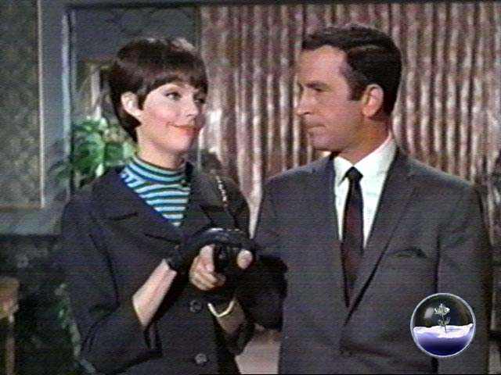
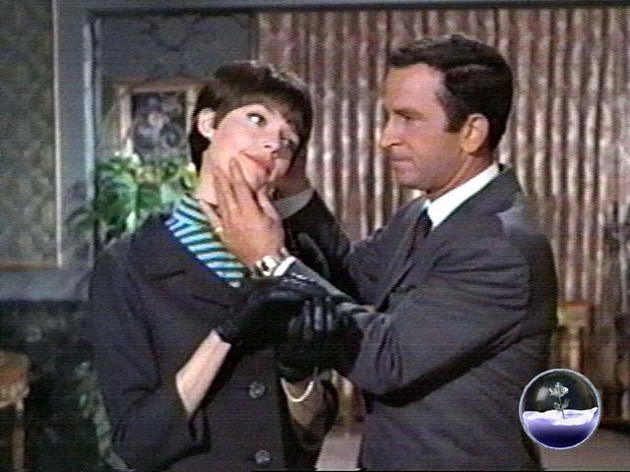


3.4: SO THIS IS A REAL THING?
NOT JUST AN INTERNET FANTASY?

Oh yes! Very much so! In recent years, the infamous Sports Illustrated swimsuit issue featured its models bodypainted like living statues. There are people out there making videos for sale to Pygmalionists. People are doing it in their bedrooms with lovers and significant others. People are exploring it with the use of hypnotic suggestion. It shows up in our mainstream media more and more in shows like Charmed, or Buffy or Smallville, or Star Trek, or The Twilight Zone. It's been around since the time of ancient Greek myth folks. No there aren't people REALLY being frozen or turned to stone, precious gems, plastic, or precious metals. But I doubt the idea will be going away anytime soon. Again, trust the Rose on this one.

Among quite a lot of Pygmalionist oriented folks, the fetish isn't so much a fetish as an artistic hyper-appreciation of the human form. And of course the self-discipline of being able to keep... still... For that matter, the idea of being a living statue or mannequin is a very real art form or profession for the talented few able to do it. The art of 'Tableaux' where people assemble and freeze up in a sort of still-life living diorama is very much alive.

3.5: SUPER! SO WHERE CAN I FIND PYGMALIONIST EROTICA?

Ooookay. I suppose you were going to ask me that eventually. In the past, a LONG while back, we had The Mannequin Lover's Homepage and The Hall of Statuary. Those have gone the way of all things, and most of the older and original pages to do with these fetishes. To Data Heaven.

Today? We have pages that have risen to fill the void left by these venerable older pages by folks like Mannequin Lover and ArgoForg. Here's a sampling of a few...

The Living Mannequin Circle
http://www.freezemodeling.com/

Stuckfast Productions
http://www.geocities.com/stuckfastprod/
or
http://groups.yahoo.com/group/StuckfastsCapturedMoments

The Medusa Realm
http://www.many-realms.net/Medusa/index.html

Indirect Image Photography
www.indirectimage.com
or
http://groups.yahoo.com/group/indirectimagephotography

Mannequeen
www.mannequeen.com

These are GREAT places to start. 'The Medusa Realm' is an especially good place to start as a jumping off point to all sorts of pages by artists and authors and producers of Pygmalionist Erotica.



4. MIND CONTROL

4.0 NOW, A WARNING???

Okay folks. This rates a second disclaimer. It must be said first, that this is a deeply exciting fetish once you look into it. I did NOT put this last because I prefer it least. It's RIGHT up there with Technosexuality for me. That said, this can also be a deeply SCARY and dark place. This can be a really beautiful place too. But it cannot be denied that the dark side of this fetish is blacker than Darth Vader's colon in a coal mine at the bottom of a black hole.

If you're looking to do anything to do with this fetish to someone against his or her will, or hurt someone's mind or personality through ritual or applied psychological abuse, this is NOT for you. THERAPY is for you. Lots and lots of therapy is for you. As well as proceedings to have your children taken care of by people they'll be safe with until you've worked out your problems. And if you disagree, perhaps a chemical castration and a nice regular dosage of thorazine is in order.

THAT SAID... Welcome. I knew you were coming. Don't ask me how. We'll get into that in a little.

4.1 OKAY. MIND CONTROL IS A FETISH???

You're darn straight it is. It has been said in the previous sections that there's a lot to do with Dominance and Submission play in the gathered group of fetishes in this FAQ. Mind Control Fetishism likely delves into that a little bit more than any other fetish I've ever heard tell of. What it is, in a nutshell... Okay, scratch that. It wouldn't fit in a nutshell. It wouldn't fit in an anti-aircraft shell for that matter. But let's give a go at trying to define it.

Fetish Mind Control has to do with achieving arousal from the practice, or perceived practice of altering the way the mind works, thinks, or perceives.

I bet you thought the definition was going to be longer than that. Trust me. Those 25 words mean a LOT more than that. (Stop counting. Yup. I knew you were doing that too. Nope, don't ask how yet. I said we'd get into that in a little while.) It's been around for a while. It's held the attention of man for several hundred years, and perhaps several thousand. And it fits into no one category. It overlaps into all manner of other fetishes, and not just the ones that come before these words in this FAQ. So. You're already going HUH?? Hundreds of years? Bulldink! I knew you were going to say that too. Bear with me. Like the man said, eventually this will all make sense.

4.2 OKAY, SMARTGUY. TELL ME AN ANCIENT INSTANCE OF FETISH MIND CONTROL.


Oh you want a history? You want examples? Picky aren't you? I've got one for you. How about one from the Bard himself? You need look no further than William Shakespeare’s play, 'A Midsummer Night's Dream'. What, you people don't read? Relax, I'm kidding. For those of you unfamiliar, the characters of Lysander, Demetrius, and Titania, Queen of Faerie are enchanted with magic love spells by King Oberon and Robin Goodfellow to fall madly and passionately in love with the most unlikely of people whilst in the woods.

And then, the legends of love spells and people being bewitched had to come from somewhere didn't they? Of course quite a lot of those stories were likely excuses to cover up for licentious, unruly, or just plain bad or evil behaviours. At least ones proscribed as bad by the reigning religion at the time. How old is the saying, 'The Devil Made Me Do It?', or some variation thereof? (And if you're interested in that kind of thing, there's fiction concerning being bewitched or diabolically manipulated too.) Legends of sorcerous sway or possession of the soul go back as far as any historical document is likely to remember. They’re as old as the idea of a love spell, or the need to not have to account for one's own actions. The CONCEPT of Mind Control is ancient.

In more modern days, who can tell when it arose again? For my own part, it's largely conjecture. Perhaps with the rise of modern psychology, when we began to scientifically try to understand the way our minds work. And the first time some mesmerist somewhere made someone quack like a duck or behave in an odd or inconsistent way? I'll lay you millions of the currency of your choice that some onlooker witnessed it and wondered how it might be applied to their sex life. The fetishist apple didn't fall far from the tree when Hypnosis bloomed into the consciousness of the world. And it was likely eaten with a lot less hesitation than Eve did in her story. And the knowledge was just as seductive and impossible to unlearn.

It likely started in its VERY modern form in the late 1800's and early 1900's, with the tales of villains and heroes and the damsel in distress. Who else knew how to cloud the minds of men? Who knew the evil that dwelt in their hearts? The Shadow knew. As soon as there was the concept of a villain in fiction, comics, film or radio, there was one that capitalized on his or her evil genius to control the minds of men or women. Prurient interest in the way super villains mesmerized poor innocent victims into doing their will has probably been just as annoying to the writers of those old stories as the parlour tricks that have dogged and undermined the credibility of hypnosis to genuine practitioners. (And if you're interested in THAT kind of story, there's plenty of those too.) Did it ever go away? Oh no...

If anything, with the advent of pulp fiction, spy stories, science fiction in its silver age, and even later, reports of drug and government experimentation in brainwashing, cults, and the like, the ideas of erotic mind control became only more and more plausible. And if you do the research, for every legitimate psychologist that's crying out that you cannot be hypnotized against your will, there's probably some government spook that will tell you, 'Give me someone's mind, and I'll make it obey.' Documented and easily researched accounts of the horrors inflicted by the U.S. government in the name of mind control exist. And believe me folks it IS horrifying reading. And it's certainly not the X-Files. If you choose to research the documented effects of pleasure/pain/drug mental conditioning as found in government experimentation, you'll wish it WAS the X-Files. The X-Files at least has the benefit of being outright fiction.

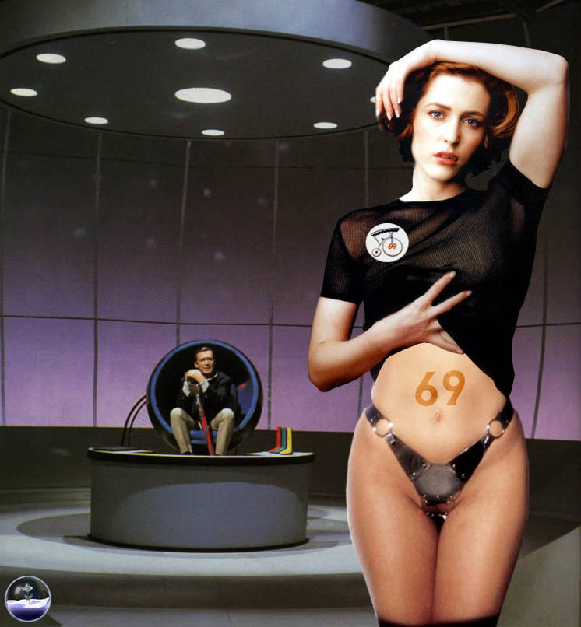
So is it any wonder that with science fact and science fiction avidly looking into the areas of mind control, that the linkage between sex and mind control was far behind? Suddenly sexy women were finding their way into movie screens and being mesmerized out of their minds by personages like Vincent Price and Bela Lugosi. Spy shows showed people under the influence of psychedelic drug or device produced mind control. (And lucky you. If those kinds of concepts really float your boat, there's erotic fiction about those too!) More common examples might include folks like Emma Peel from The Avengers, or Batgirl, in Batman, or any number of Sidney Sheldon sitcoms. Or maybe in one of the most infamous moments in television history in the 60's, the first televised interracial kiss. And of course, it had to be Star Trek didn't it?

In the classic episode, 'Who Mourns For Adonais?" Captain Kirk (William Shatner) and Lt. Uhura (Nichelle Nichols) are under the mental domination of a super being calling himself Apollo. He's left them perfectly aware of their situation and isn't causing them to think any differently than they normally would. Control of their bodies however has been taken completely away from them. And 'Apollo' totally to satisfy his whim, and humiliate them, has Kirk embrace Uhura and kiss passionately. It has been said that the element of mind control was introduced into the scene in order to justify the kiss between a black woman and a white man at the time. (Perhaps believable since producer, Gene Roddenberry had kissed Miss Nichols too, if the accounts of Majel Roddenberry are taken into account) Because it was forced upon them, the kiss became acceptable to network censors. Some viewers received the kiss as happily as it rejected by others at the time. I find it quite ironic that in this instance, while the element of mind control was introduced to make the kiss acceptable to the masses, it also in turn eroticised the mind control itself. Later still, there was the episode, “Whom Gods Destroy”, which took place in an asylum colony for the mentally deranged. Kirk is put into a sort of conditioning machine and conditioned mentally to love someone against his will.

In the 70's and 80's, alternative therapies and books on Hypnosis and Self-Hypnosis made available to the public brought even more experimentation and fascination with the idea. Meditative and introspective therapies made their way into the mainstream. And Hypnosis, while still retaining it's mystique, and questionable credibility, was a lot more understood by the masses. No longer was the practice some mysterious tool of quacks and villains from Republic serials. It was a tool for exploring the inner self and subconscious. It was a way to kick annoying habits like smoking or probe the neuroses that cause us pain.

Does that mean that this new understanding precluded thinking about taking control of the mind in a sexual way? Oh HELL no. It meant that we could now attempt to disarm all the puritan hang-ups and sexual dysfunctions in the mind by probing the sources of the guilt and shame associated with sexual enjoyment. And we knew there WERE some too. We also became aware through books like 'My Secret Garden' by Nancy Friday, that women had JUST as many prurient sexual fantasies as the men folk. And we had ideas on how to start exploring those fantasies in one another with roleplaying and kinky sex play. The S&M people had been doing that for years. The D&S people were also doing it. And of course, the idea of Dominance and Submission and Hypnotic exploration and roleplay? To see the way the two fit so neatly together, it's enough to make someone believe in fate. (And OH are you on a roll! There's fiction about this kind of mind control play as well!)

As with Technosexuality, now we get the advent of the Internet. And people that had been writing their fantasies into nice erotic bits of fiction all this time began sharing them with one another on bulletin boards and the usenet group, Alt.Sex.Stories. And inevitably, as people on the internet will do when they find something that interests them, the Mind Control oriented stories were collected on a homepage and shared. Unlike the rise and fall of the techno or statue fetish pages on the net, the one repository of Mind Control Fetish fiction online has remained constant. It's gone dark once or twice. But Simon Bar Sinister's 'Erotic Mind Control Story Archive' has been around for 8 plus years as of this writing. And it's still updating every week. And the writers there show no sign of stopping. They're producing more and more. And if you enjoy or want to support the page staying online, donations are always being accepted.

As a side note, the esteemed author, Boris Ludmenkov used to have an essay on the nature of mind control erotica on the EMCSA that comes as close to anything I've seen to a FAQ for the subject. He was gracious enough to share a copy with me from the deepest darkest recesses of his computer's hard drive. I may quote his more venerable work, 'Mind Control: An Essay.' from time to time.

Soon enough, as more and more pictures were scanned and the internet porn culture established itself online, people started to collect pics that looked like mind control stuff; in some instances, themed pictorials from magazines about just that. And when image-editing software like Paint Shop and Photoshop made it to the public? People started converting their favourite pictures or pics of their favourite celebrities into mind control pics of all sorts. There are even pages of the free and subscription sort that have been around nearly as long as Simon's EMCSA, devoted to nothing but the preservation and exhibition of Mind Control digital photo manipulation work.

And now that free and easily made BBS's and clubs and user groups have made their way to people online, there's places where people as avid as any fetish community share information about ideas, methods, safe and sane fetish hypnosis practices, and instances of any related material in the mainstream media. And surprise, surprise, who knew there was so much down through the years?

The people into it did.

4.3 SO WHY WOULD ANYONE BE INTO THIS?

One word. Power.

Plain and simple power ladies and gents; its exchange and use to satisfy yourself or another. And sexual gratification is all about satisfaction isn't it? And control is power, folks. It's who's in control or what that control means that isn't the plain and simple part.

Is there REALLY any need to try to explain why a dominant kind of person might be into this? Actually yes. It can go without saying how natural the combination of dominant sex play and mind control themes go together like chocolate and caramel. (Sweetly.) But the fantasy can do more than just provide an outlet to be ruthless and controlling in all the ways we can't be in real life. It provides a safe framework for indulging in those fantasies without guilt or repercussion. It IS a form of what's referred to as edge play, where boundaries are tested and what's considered safe can be pushed. The dominant person is actually EXPECTED in this case to be the Evil Scientist or Villain that we can't be in polite society. Everyone knows the archetype. It goes back to old villains like.. Well, all the ones we were first acquainted with as children. Snidely Whiplash, Oilcan Harry, ... Simon Bar Sinister, or any number of classic cartoon villains that you ever heard say, "Aha, my pretty, now you're IN MY POWER!!! BWAAAHAHAHA!!!!"

Does that mean it's all about villains taking power from another? Not hardly. It can be a very loving and EMPOWERING experience where the dominant can be not only an authority figure, but a healer and a force for positive change or intensely pleasurable sensation. There's all sorts of positive overtones that can come with dominance as well as negative. And the potential for good and romantic overtones in the realm of Mind Control? There's every bit as much possibility for the hypno hero and saviour as the villain and corruptor.

Just as well, there's reasons beyond the obvious for submissives to be into Mind Control. And they run akin to the ones up in Technosexuality. Here's a guilt free way to give up control in every last way to your dominant. For every sensitive dominant out there that felt slightly bad about taking the power away from their sub, no matter how consensual it was, there's a strong willed sub that feels JUST WRETCHED because they just GAVE their power away, or didn't feel they were submissive enough to satisfy. There's that word again. Satisfaction.

In the Mind Control fantasy, the controlled submissive doesn't have to feel guilt. They don't have to feel the slightest bit bad or nervous that they didn't satisfy. They don't have to FEEL period if the fantasy doesn't call for it. They have no will to feel bad about giving away. They have no will beyond that of the person in control. They are THAT completely in the thrall of the dominant. The Mind Control fetish can be a key for any submissive to REALLY dig deep and be COMPLETELY DOMINATED at last. Free at last, free at last. To be enslaved as they wanna be.

And again, like with Technosexuality, the exchange of power is happening on more than just that level. The controlled person is sustaining the fantasy for a large part for the dominant. And vice versa. However UNlike the other forms of fantasy-based sexuality in this FAQ, a talented individual can actually DO this to some degree. Hypnotism can be learned. Someone can learn to be a good hypnotic subject. And considering the inherent consensuality involved in healthy hypnosis, there's a huge amount of symbiosis happening here. “But wait!”, I hear you saying...

4.4 CONSENSUAL MIND CONTROL? ISN'T THE IDEA OF MIND CONTROL NONCONSENSUAL? AND IF SO, ISN'T THIS A RAPE FANTASY?

Okay. This is an argument that’s still raging today. Is the reality of mind control consensual or not? There are camps on either side of the debate that are completely convinced of their argument's validity. For my own part, having researched the matter a little, I see it this way.

Healthy hypnosis is, by it's nature, consensual, otherwise it doesn't really happen or work. Now back up a second before all you people that believe in hypnotic rape gang up on me. Read what I typed. HEALTHY Hypnosis. IE: Hypnosis or mind control techniques employed by two consenting adults. Because they ARE consenting adults where one trusts another enough to give them access to their mind, the subject cannot be hypnotized to do something like go out and kill someone, or do something fundamentally against their nature. Usually if such is attempted, the mind's natural defence mechanisms knock the subject RIGHT out of hypnosis. (The technical term for this is referred to as an Abreaction.) And then it's time for a talk, as with ANY situation between partners that have hit a snag. BDSM people might rightly see this as the mind exercising it's right to call a safe-word to protect itself.

For those of you that aren't aware of the meaning of safe-word, people that indulge in S&M often agree in negotiations beforehand on a signal or word that means they're REALLY not enjoying the pain they're experiencing. Or have become frightened or worse, are having a more severe emotional reaction than they can cope with. Essentially it always means "OKAY STOP. I REALLY MEAN IT. I'M IN TROUBLE AND I NEED HELP. WE NEED TO TALK OR YOU NEED TO ATTEND TO MY HURTS NOW."

Those that believe that you can indeed be conditioned to behave against your will can point to the examples of Mind Control Experimentation by intelligence organizations, cults, and abusers all over the world. And yes there's recorded scientific documentation of the techniques employed by these TRULY ruthless and evil people that substantiate that claim. But again, consider. This is FAR from healthy hypnosis. In many instances, it's merely classical conditioning crossed with alternating pleasure/pain torture methodology, often combined with altered metabolic or neurological states produced through sensory or sustenance deprivation, or the application of Psychedelic, Psychotropic, or Soporific drugs. And all of that's meant to bypass the mind's ability to protect itself. Does that sound healthy to you? If it does, stop reading and go re-read the second paragraph of section 4.0. Then go seek help before you destroy someone's life. What are you doing still reading? Be off with you!

As for Rape fantasy… The idea of rape fantasy as a means to explore one’s shadow self is not at all uncommon. Indeed, if one looks into more psychological studies and books written on the subject of erotic fantasy, the rape fantasy seems to be one of the more common themes among women. Does that mean they all want it? Umm, if you just asked that, I suggest that you didn’t stop reading and go to get help for yourself when I told you to. If you are that person GIT! VAMOOSE!

That said, NO ‘they don’t all want it’. But all the same sometimes it’s a safe way for people or couples to explore their darker sides in a safe way that can be STOPPED when they need to. For some the rape fantasy can even be a way of lessening the impact of an actual rape in their lives. It can be a sort of elimination therapy where the horrific event is re-enacted, but control is retained by the victim, kind of like counteracting a disease with a weakened version of that same malady. One could go on and on. But that’s not why we’re here.

How does that fantasy play on Fetish Mind Control? Jeez, you have to ask? In a lot of stories, pictures and fantasies, the concept is all about perceived nonconsensual eroticism? The controlled is helpless and unable to do a single thing about it. They’re at the mercy of their captor/hypnotist/villain/whatever. Forced to do things they’d ‘NEVER EVER’ do in real life. And of course the controller can indulge just as much. Hopefully none of us would EVER go out and do some of the more horrible rape fantasy things that can be found in Fetish Mind Control themes from time to time. But so long as you harm none, there’s no harm indulging safe fantasy is there? Relax folks. HOPEFULLY it’s all in good fun. If it isn’t, it bears repeating like the waves hitting the beach from the ocean. Go get help before you escalate into the real.

4.5 SO, SMARTGUY, WHAT KINDS OF MIND CONTROL EROTICA ARE OUT THERE?

What forms can Mind Control fetishism take? How many can you imagine? The proper answer there is more than you or I could think of or list here. For the sake of convenience however, I’m breaking it down into the most readily find-a-ble forms. First, we’ll have a look at…

PICTURES: As with the other subjects in this FAQ, Mind Control fetishism has been around a long time in images. From the plays our ancestors watched onstage, to the movies and comics and cartoons and television shows our parents watched and all unwittingly, exposed us to. Like with Technosexuality, the play in the media it gets is unmercifully brief. You’ll have to be handy with a VCR and the like to get that moment of possession, hypnotized heroine in peril, or whatever it is that grabs you and mesmerizes you in front of your screen.

However, porn-wise, Mind Control fetishists are a little better off than the other fetishes in this FAQ. There’s lots more Mind Control porn-movies out there than one might initially think. They’re easier to find too. An added bonus to this one being that it doesn’t have to be some poorly scripted thing where the dialogue is gotten out of the way as quickly as possible before people start ramming things into one another. Because of its very nature, there’s a little more plot required to make the situation believable. It can still be pretty spare too though, so be warned.


Another added bonus to this one is that since this is a fetish you can actually try to indulge in for real, as opposed to not actually being able to turn into a robot or a statue or have relations with one, there are videos out there where the mind control you’re seeing is supposed to be REAL. Whether it’s actually real or not I’ll leave up to the opinion of the viewer. But the possibility exists for you, dear reader, to go right on over to some page or other that sells videos of stage hypnosis, or just plain erotic hypnosis and have something in the mail on its way to you in less than an hour.

Nowadays, with the advent of image-altering software, like with the other fetishes in the FAQ, people have also jumped onto the idea of creating all the mind-control images they can whim. I’ll get into what sorts of things they do in those images in a little bit. Why? Because, my dear reader, quite a few of those concepts are also covered in…

FICTION: There is a lot of this. OH is there a lot of this. Before the esteemed Simon Bar Sinister started up the best archive on the net for this, there were stories coming down through the newsgroup, Alt.Sex.Stories pretty regularly. Sometimes people would collect them and post them all in a bunch. If you go to any fetishist kind of fiction archive, be it Latex or Trans-gendered in theme, you’ll likely always find a sub-category of Mind Control that you can search out stories by. For that matter, you’ll find sub-categories for the other subjects covered in this FAQ as well more often than not.

Nowadays, you can go to the online repository for Alt.Sex.Stories (And leave a donation. Just like Public TV!) and search out a fraction of how much there is out there. Likely, you’ll find yourself directed to Simon Bar Sinister’s Erotic Mind Control Story Archive. This is NOT because there isn’t a wealth of subject matter on the topic. It’s because Simon’s site is pretty much THAT comprehensive. There have been some writers that have asked that their stories be removed from his site. (Who knows why?) And some years ago, he made the decision to remove all the stories that involved Transsexuals or Transgenderism. Is that a problem? Oh no. What you don’t find on those two issues on Simon’s site, you’ll find on the home pages of the authors that had their stories taken down. If you were really hoping for the trans-stories, you’ll want to go to the Fictionmania archive. That’s nothing BUT trans stories for the larger part. And they do have a searchable category for Mind Control.

When you go looking, as with looking for music on mp3 sites, you’ll find fiction that ranges from the extraordinarily talented to abysmally inept. You’ll find some that perhaps run a page and a half, to long and continued series that run into the hundreds of pages. (So be careful before you decide you’re going to make hard copies of everything you find. There’s nothing quite like the shock of printing out a story and seeing that good old popup window tell you, ‘NOW PRINTING PAGE 1 of 194’)

Some of these stories are very much like the no-nonsense Flim-Flam-Trance-You-Ma’am sex stories you might find in a Penthouse Variations letter. There could be token bit of watch-waving or subliminally laced videotape and suddenly lots of sex and nothing else. On the other side of the coin, you can also find near novel length stories where the emphasis is clearly on the mental transformation of the characters involved, with lots of situational and interpersonal development. And the very occasional bit of whoopee. Or any mix of the two extremes for that matter.

REALITY: Like I said, this one can actually be performed on your willing participant to a large degree. There needn’t be any kind of special effects. No props like Metronomes, Watches, Candles, Crystal Pendants or what have you. All there really has to be is a consenting adult. (There doesn’t even have to be two. Self-Hypnosis is right up there with the possibilities.)

In the video side of things, like I said, there’s all kinds of videos you can get where erotic hypnosis is the theme. The difference being that in the reality-based videos, the hypnosis you see is presented as being real. Also, like I said, it’s up to you to decide whether the subject is really under of just acting that way. But for some, the realistically presented illusion of the idea is quite enough.

On the literary side of the reality coin, there’s all kinds of books out there recounting the experiences of those that have tried erotic hypnosis in real life. For that matter, there’s all manner of books out there that are meant to teach you how to introduce it into your life or relationships for self-improvement, healing, or just plain adding spice to your sex-life. Try a search for ‘Erotic Hypnosis’ on a major online book store’s site. You might be surprised at what you find.


There’s another aspect you might want to know about. The online aspect. With the advances in audio and visual presentation technologies and DSL, the possibilities exist for flash-animated websites meant to encourage hypnotic states. There’s sites out there like WarpMyMind.com that offer MP3 files for free on all manner of erotic hypnosis inductions. If you find the right sorts of online groups out there, you might find weekly online chat sessions that support audio; ones that do inductions in real-time, live, online.

And finally, there’s the realm of the online Hypnoteuse. These hypnotically dominant women can range from the very caring mind expanding experience-giving sort to the very acquisitively abusive and harsh type. But they all seem to offer, for a price, recorded sessions of hypnosis on CD or MP3. Some of them go as far as offering for a price, telephone sessions in real time, or custom recorded inductions for a specific listener.

It should go without saying here, that hypnosis in its healthy form could still be abused. Extreme caution should be taken when entrusting your mind to someone online. More so than anything else in your life. No you’re not likely to be brainwashed into going out and killing someone, but pleasurable feelings can be post-hypnotically assigned to obedience. And over time and repetition, for a person that gains pleasure from submission anyway, that kind of obedience can be abused in all sorts of ways that wouldn’t trip someone’s inner defence mechanisms. This isn’t to try and put you off the online aspects of hypnosis, but it’s meant as a reminder that you look out for yourself as you would with anyone on the other side of the wires from you. There are good people out there. And there’s also creeps. And with your mind literally on the lines, you’d want to be THAT much more careful.

And I WILL say it again. If you’re considering taking advantage of someone hypnotically, stop reading. Get help. You really need it as badly as someone doesn’t need to be taken advantage of by you. Go now.

4.6 OKAY, BUT WHAT ELEMENTS SHOULD I LOOK FOR THAT MAKE A GOOD MIND CONTROL FANTASY OR EXPERIENCE?

Yeah, I did go on a bit. The previous section was mostly about the three main forms you’re likely to find. If you’re into this already, you already have a fairly good idea what entrances you and leaves you spellbound. But if you’re not, or are perhaps just getting into this, this section is meant to point out the elements you’d be looking for in a story or picture or whatever to be able to point at it and go, “OH! Okay. Yeah. Herbie the Mind Control Guy will really get his rocks off when he sees/reads/hears this.” Jumping right in, we come to…

INDUCTION/TAKEDOWN: And yeah, there’s even sub-categories to this. And likely I’m not even getting them all. I’m just trying to sort things out into as general and all-inclusive terms as I can. But in general, Induction/Takedown refers to the manner in which the Controller initiates control of the Controlled. Like I said, it takes as many forms as you might imagine. But in the erotic sense, it seems to fall in these categories:


1. Realistic: Mind Control of this sort is exactly what you might expect. Methodologies of Hypnosis, Classical Conditioning, Torture, or basically, any technique that could realistically (or at least believably) be duplicated in the real world are what you’ll find here. The pictures of such things usually involve all the ubiquitous props of the hypnotist; Metronomes, Crystal Pendants, Swinging Pocket Watches, and lots of long and involved induction speech or text.
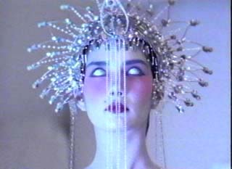
2. Fantasy: Here you’ll find all manner of magic crystals, spells, and magical doodads and personages magically controlling the person or persons of their choice, causing mental and physical transformations that go far beyond what you might consider reality. You might also find spiritual possession or corruption to be prevalent themes.

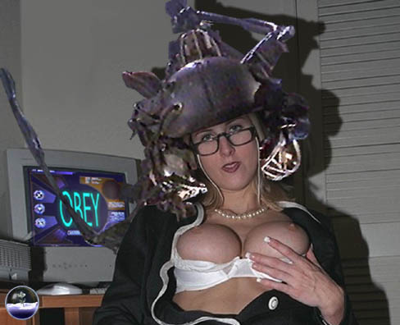
3. Technological: In this kind of thing, you’ll find more sci-fi aspects of the idea. Strapping helpless people into brain altering devices or implanting them with all kinds of things that change them physically or mentally into the dominated servant the controller craves. Nanotechnology and lots of Technosexual aspects tend to overlap into this area. This needn’t be entirely unbelievable, however. You might include top-secret brain altering drug injections into this mix too. Or perhaps pheromones. Or aliens…

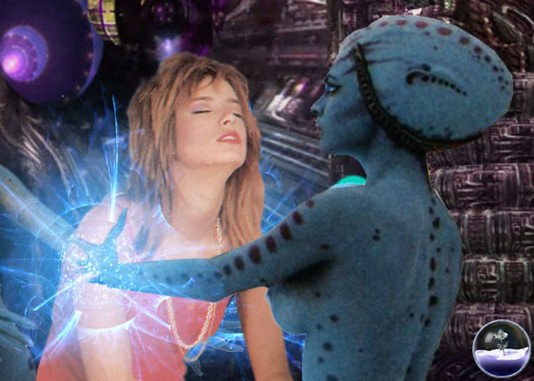
4. Psychic: This deserves its own sub-category cos there’s just so darned much of it. It could be seen as a mix of the previous three really. Not exactly fantasy or science fiction, yet a little of both. And possibly realistic, that is, if you believe in psychic phenomena. In this category, you’ll find people/creatures with advanced telepathic prowess reaching out and psychically altering their subject’s thoughts or personality or behaviour with just the thoughts in their heads.

And if I’ve left something out here that you think deserves its own sub category, let me know. I’m certainly (AHEM) open to suggestion on the matter.

APPEARANCE: Okay, with the other fetishes in this FAQ, you usually get pretty clear indicators of the person involved being mechanical, dolly-fied, or petrified or what have you. But Mind Control is quite often, a mental state only. How does one visually simulate the idea?

A lot of times, the eyes again are key indicators. In more realistic erotica, the blank look, glazed stare, sleepy eyes, dilated or constricted eyes, or eyes rolled up into the upper eyelids can be sure signs of mind control. That’s an idea that goes back to your childhood if you read comics. Remember that? Any time you ever saw someone getting their mind controlled, their eyes seemed to go blank white? Blank black eyes are being used that way nowadays as well. The terms for these seem to have defaulted to ‘Whitewashed and Blackwashed’

It needn’t just be the eyes either. Said person could be sporting implants. Cables trailing from them to computers. A bit of hanging drool from the mouth. Attatched devices, rings, pendants, jewelry, held props or whatever. Basically, any external sort of evidence, object, device, doodad, or trinket that you can see with the subject that helps you suspend your disbelief and mentally see a person as entranced can be included here.

Posture can denote a hypnotic state. The old pose of standing stiffly at attention can be indicative of Hypnotic Catalepsy. Or perhaps the person looks so relaxed they’re asleep. Or perhaps someone that just looks drunk or tired or fatigued could be seen to be entranced. Posture-wise, what makes someone look as though they’re hypnotized is really going to be relative to the viewer. Luckily enough, there’s enough instances of the idea that you’re GOING to be able to find what moves you. Even in mainstream erotica or media that wasn’t intended to be that way. Have fun!

BEHAVIOUR: You and I both know it. But I’ll say it anyway. Someone under mind control doesn’t act the way they normally would. Otherwise, why would someone be exercising that control over them to affect that behaviour? In this case however, you get the full range of behaviour, depending on what the beholder perceives hypnotic behaviour to be like.

One person might enjoy the idea of their subject acting as they normally would within the limits of a post-hypnotic suggestion. IE: Unable to remember their name, or perceive that they have no clothes on. Another person might want the old wide eyed blank stare, monotone voice, and walking around with their arms out in front of them ‘Yes Master’ kind of thing going on. Or perhaps a drugged, sleepy kind of behaviour with a whispery innocent sounding voice… Or anything else your mind may crave to excite itself with.

HUMILIATION: Okay, this one is admittedly not my biggest cup of tea, but never-the-less, it IS a prevalent theme. The idea of making someone or being made to do something entirely mortifying is a big turn-on to some. In this one area, I feel really ill-equipped to write at length. There’s all sorts of literature out there on the operative psychology of erotic humiliation. Go find some. Or if you’d like, I encourage you to submit to this FAQ a more detailed explanation of the idea. But if you can’t see the potential in Mind Control fantasy to inflict humiliation on a subject, there’s really not much I can say to explain it.

CELEBRITY: This one wouldn’t be as obvious from the get-go, but the idea is very much there. In the fantasy sense, there’s a desire by a great many to subjugate or be subjugated by a celebrity, supermodel, fictional character, or famous whatever. There’s all sorts of fiction out there concerning the control of celebrities or superheroes or public figures or what have you. There’s entire groups out there devoted to nothing but the photomanipulation of celebrities or fictional characters or genres of media, or specific races of human being.

4.6 RIGHTY-O, OLD MAN. WHERE CAN I GET SOME?

Well firstly, I’m not old yet. Secondly, where you get some is up to you. If you mean where can you get some Mind Control Erotica, I can be of some assistance there. Here are some pages to get you started.

The Erotic Mind Control Story Archive
www.mcstories.com

MC Forum – The Mind Control Fiction Message Board
66.37.7.139/plus/plus.mirage?who=mcforum

The Fictionmania Transgendered Fiction Archive
www.fictionmania.com

The Privatepages Realm of Entrancement
www.privatepages.com

William Lee’s MC Image Workshop
members.tripod.com/wl300/photoindex.html

Hypnosis & Mind Control in the Movies
www.geocities.com/area51/nova/6192/

JR Parz’s Erotic Mind Control Stories Home Page
www.asstr.org/~JR_Parz/

Warp My Mind.com
www.warpmymind.com

Yahoo Group: Hypnopics
groups.yahoo.com/group/hypnopics

Yahoo Group: Hypnotic Femdom
groups.yahoo.com/group/hypnotic_femdom

Yahoo Group: Erotic Hypnosis
groups.yahoo.com/group/erotic_hypnosis

Yahoo Group: Erotic Hypnotapes Discussion
groups.yahoo.com/group/erotichypnotapesdiscussion

There. That ought to pretty much take you to places that will bounce you all over the place for more MC content if you aren’t completely blitzed by all these folks have to offer you. If there’s a place you think should have been mentioned that hasn’t, I urge you to let me know. I’ll see what I can do about getting into the next revision of this FAQ. And certainly let me know if you’d like to be credited for your suggestion. Thanks in advance! Oh. You wanted to know how I knew all those things at the beginning of the MC part of the FAQ? That was humour, gentle reader. No need to fear…

Or was it?

I knew you’d be wondering that too. -_o

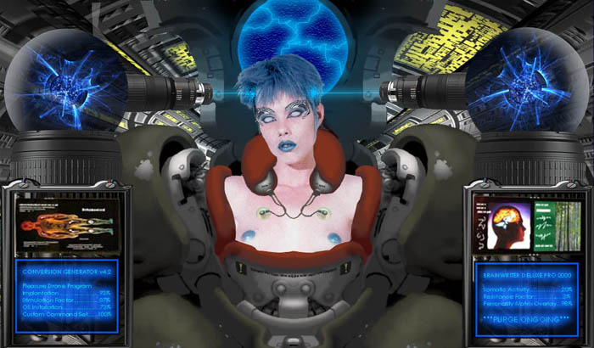
APPENDIX I
Other Related Fetishes

Have I touched on everything here? Not by a long shot. The things folks are aroused by are only limited by their imaginations, basically meaning there IS no limit. There's the Superhero Fetish. The Sleepy Fetish. And all SORTS of more well known kink that the above interests cross over into. As with anything, follow your nose and find what you're interested in. If you want to look into some of these other kinds of thing, Here's a few links to start your explorations with...

The Alt Sex Stories Text Repository
http://www.asstr.org/

Sexuality.org: The Society for Human Sexuality
http://www.sexuality.org/

You likely have anyway if you're already familiar with the internet. If you're not, I hope you enjoy your trip. And I hope I've helped.

APPENDIX - II
People who were nice enough to contribute their
opinions, questions and answers.

"I'd like to thank the academy..."
-Tyler Durden, 'Fight Club'

You really can't have a Frequently Asked Questions unless people actually ASK questions. And like the Baz Luhrman song goes, the rest was the thoughts and opinions based on my own rambling experience. When composing this document, I consulted the original ASFR FAQ first. So of course the first person that I need to thank here is Robotdoll. Without his efforts to drag Technosexuality kicking and screaming into the daylight (or is that klanking and screeching?), so many of us would still be out in the cold, and we certainly might not be the community we are today.

Boris Ludmenkov needs to be thanked for the contribution of his fine essay, 'Mind Control: An Essay' to get an idea of the sorts of thing I ought to mention. His work on that essay was as inspiring and impressive today as it was back in the day.

As well, the past efforts of Mannequin Lover, and the continued efforts of people like Simon Bar Sinister, Robo-Lover, D.Muk, Href, Noidguy, Dosman, Monza, Vengeance, KingJeremy, Kishin, Android69, and Keraptis.

And especially Silver Karakuri, Flambeau and my favorite kitty, Hepzibah. My faith in my fellow beings was restored by you three.

APPENDIX - III
Where the pictures came from and who made them.

In an attempt to be honest about the fair use of the images contained within this document, I have tried to make the effort to credit their creators, or at least the pages I downloaded them from before I used them in this document. It's not ALWAYS possible however. It needs to be said that no profit is being realized from the dissemenation of this document. If you got it on a page that charged you money for access to it, the people running that page are stealing from you, me and the person that made these images in the first place. And I'd quite appreciate the URL of the page so I can tell them to cease and desist and get my cut of the money they made from my writing and research.

All photomanipulations by Edward Gore are protected by parody statutes put forth by the First Amendment of the Constitution of the United States of America. No profit has been, or will be made from this image by the altering artist. This image is not an attempt to profit from, or infer defamation of the persons, artistic intent, or depicted situations contained within the original image. Neither have the images been presented in any attempt to dilute existing trademarks to whom said original images belonged to. The images are intended as fiction and should not be seen by anyone as a depiction or inferrence as to the character of the persons depicted within said images. Any image by Edward Gore MUST be distributed with this disclaimer attached. Copyright 2003, Edward Gore. All Rights Reserved. Support Freedom of Expression!

- Page 1: The ASFR FAQ Cover, by Edward Gore © 2002-12-02
- Page 4: ‘Head Trip’ by Hajime Sorayama
- Page 5: 'Pygmalion & Galatea' is from the online edition of © Bulfinch's Mythology
- Page 6: ‘Rotwang, Maria and Hel’ from Fritz Lang’s ‘Metropolis’
- Page 6: ‘Jean Marsh as Alicia’ from ‘The Twilight Zone: The Lonely’
- Page 6: ‘Katherine Ross as Joanna’s Robot Replacement’ from ‘The Stepford Wives’
- Page 7: ‘Darryl Hannah as Priss’ from ‘Blade Runner’
- Page 7: ‘Denise Crosby * Brent Spiner as Yar & Data’ from ‘Star Trek: The Next Generation –
The Naked Now
9. Page 7: The Robot and Verna, from ‘Lost in Space’
10. Page 9: Dick Van Dyke & Sally Ann Howes in ‘Doll On A Music Box’ from
‘Chitty Chitty Bang Bang’
11. Page 10: Pamela Gidley as Cherry 2000 from the movie, ‘Cherry 2000’
12. Page 11: Emma Williams as Truly Scrumptious in ‘Doll On A Music Box’ from the stage
production of ‘Chitty Chitty Bang Bang’.
13. Page 11: Shields & Yarnell as ‘The Klanks’ from a Press Photo
14. Page 12: Exploding Vanessa from ‘Austin Powers: The Spy Who Shagged Me’
15. Page 12: Lexa Doig as ‘Andromeda Ascendant’ from ‘Gene Roddenberry’s Andromeda’
16. Page 12: Ashley Scott & Jude Law as Mechanical Prostitutes from Stanley Kubrick and Steven
Spielberg’s ‘AI: Artificial Intelligence’
17. Page 13: Unknown Actress from ‘Extreme Sex 3’.
18. Page 13: ‘Starstruck’ style Fembot, by Edward Gore © 2001-2002
19. Page 18: Nano Guitar, found online in a press clipping. Link provided w/picture.
20. Page 20: Mai series Realdoll, by Abyss Productions.

21. Page 21: ‘Coppelia’, from the BalletMet production poster for the opera ‘Coppelia’.
22. Page 22. Sexy Doll Costume found on some Halloween site. Unknown Location.
23. Page 22. Dita Von Teese as a Bondage Marionette.
24. Page 23. Miranda as a timestopped doll, Hotmoon Productions
25. Page 24. Jenny series Realdoll, by Abyss Productions
26. Page 26: Granite Looking Male and Female, Unknown Source
27. Page 27: Changing Skin Tone to Matte, by JLS
28. Page 29: Sophie Ellis Bextor, from her music video, ‘Get Over You’
29. Page 30: Scenes from ‘Our Man in Leotards’ from the series, ‘Get Smart’
30. Page 30: Greek Nude Living Statue. Unknown source, suspected Sports Illustrated.
31. Page 32: Some Pictures Don’t Need a Caption, by Edward Gore © 2001-2002
32. Page 33: Kevin Kline & Michelle Pfeiffer as Bottom and Titania from ‘A Midsummer Night’s
Dream, by William Shakespeare’ (1999)
33. Page 34: The New Number 69, by Edward Gore © 2001-2002

34. Page 34: William Shatner & Nichelle Nichols in ‘Star Trek: Who Mourns for Adonais?’
35. Page 38: Electrotorture Fetish Pic culled from the Usenet. Unknown Source
36. Page 39: Miao-Yen goes Surfing 01, by Edward Gore © 2001-2002
37. Page 40: Bronwyn’s Live Feed, by Edward Gore © 2001-2002
38. Page 41: A hypnotized girl from a page that scammed a lot of people. Nameless here a’purpose.
39. Page 41: Suzee Pai as Mystically Mesmerized Miao-Yin, from ‘Big Trouble in Little China’
40. Page 42: Arundsen’s Device, based on a Story by Tabico, by Edward Gore © 2001-2002
41. Page 42: Alien Abduction, by Edward Gore © 2001-2002
42. Page 45: Pleasure Drone Conversion Generator, by Edward Gore © 2000-2003
43. Page 48: The WinterRose Photomanipulation 2002, Edward Gore © 2002

More thanks go to my favorite Kitty, Hepzibah, who was nice enough to vidcap some of these for me. Scritches and lots of em for you!

APPENDIX - IV
Who is this WinterRose person anyway?

WinterRose (originally WinterMute) became aware of the Technosexual, Mind Control, Pygmalionist and Doller communities in 1994 or 1995, such as they were, and contributed to the original ASFR FAQ by Robotdoll and Leem under the name 'Innocent'. He lurked for a while when he had no computer to call his own between 1996 and 1998, then started producing his own photomanipulations, writings and roleplay based technosexual characterizations in the #ASFR chatroom on IRC. As he became more active in related ASFR and MC bulletin boards, he decided to become more prolific, or at least as productive as he could whilst trying to survive, and give back images and feedback to the community that had provided so much for him.

On Privatepages.com, he contributed the bulk of his MC related Photoshop work. Later he opened up a few Lycos clubs to fill the need for props for other photomanipuators to use in fetish image-alters, as well as an escape hatch for people in the related Yahoo groups to congregate at, should those groups suddenly vanish without trace. There he provided reviews for new ASFR and MC fiction for a while. He has since worked on what inspiration calls him to do at any given moment. His more recent projects have been the Bestiary, a personal page based on his online persona, WinterRose the Gynoid. More recently still he's worked on what promises to be a small novel length ASFR story, the FAQ you're reading now, and a page devoted to the production and free dissemination of MP3 readings of popular Technosexual and Mind Control fiction.

WinterRose is a 31 year old caucasian male. He considers himself 98.5% heterosexual with an open mind to the remainder. He is active in his local BDSM community and identifies as a switch. He has in his time been an actor, an author, a poet, an artist, an animator, an audio-performer, an editor, amateur hypnotist and hypnotic subject, and any number of other things one would think a person trying to find and focus their creativity might try their hand at. He maintains that more than 12 hours a day of Television, Porn, Cartoons and Japanese Animation, Comics, Alternative and Subversive Music, Videogames, Junk Food. Roleplaying, Movies, staring at a computer for most of his free time, and other things that most moral types say is bad for you can be destructive to personality and the imagination and offers himself as an example.

-WinterRose



"You're still here? It's over. Go home. Go."
-Ferris, 'Ferris Bueller's Day Off'

